Spring OVERVIEW YEAR 3/4 – Art

Spring Term Book – How to Train your Dragon
Topic(s) – Create a close up image of a dragon’s eye using oil pastels and paper layering.
Assessment: | Evaluation and critique of own art work.  Reflection on which skills they found easy/ hard and what they will try to improve going forward.  Reflecting on peer’s artwork and offering each other constructive feedback based on the art they have produced. | Very Important Points (VIPs):  - Oil pastel (also called wax oil crayon) is a painting and drawing medium with characteristics similar to pastels and wax crayons.  - Oil pastels blend very well and you can layer colours up very quickly.  - Oil pastels can be blended using different techniques including with your fingers, tissue, dotted lines and pressure control.  - Rubbings are often classed as one of the oldest forms of “print making” – by rubbing a soft pencil, crayon or pastel over a surface and reproducing the raised elements of that surface you are reproducing an accurate “print” of it.  - Paper layering is exactly what it sounds like – placing different pieces of coordinating paper on top of each other to achieve a “layered” look.  - A paper sculpture is simply several layers of cutout paper that enhances and defines the image, making the 2D paper look as though it is 3D.  Fat Questions:  Does writing, for example a novel, influence art or vice versa?  Is a piece of art ever finished? How do you know when to stop?
Links to prior learning (sequencing) and canon book | Link to canon book ‘How to Train your Dragon’ by creating a ‘dragon’s eye’ using different mediums.  In KS1, children used soft pastels to create a scene of the Savannah.  In Year 5/6 children will use a range of media including oil pastels to create mythical images and war imagery.
Links to other learning (cross fertilisation) | English- myths and legends about dragons and newspaper reports about dragon sightings  Reading- Link to reading canon novel 'How to Train your Dragon'  Maths- 3D shapes. In this unit of work we will use paper and card to create a 3D layering effect.
Links to future learning | In upper KS2, children will continue to practise techniques across a range of different media including oil pastels and paper layering.
Character/Wider Development ('50 things', cultural capital, skills) | Go outside into nature and collect items to create oil pastel rubbings.  Take photographs of our work at different stages and record the process.  Thematic Questions  The World Beyond Us  Can art help us to understand the world beyond us?  Modern Britain  Modern British artists create a variety of different works. Do you agree?  Healthy Bodies & Healthy Minds  How can art benefit our mental health?  The World Around Us  Does the environment where you live have an impact on the type of art that you produce?  Culture  How can the artwork of other cultures help us to understand them?  Technology in Action  How can maths be used to create art?

OVERVIEW OF TEACHING SEQUENCE
Key Facts/Learning | Learning Focus or Key Question | Learning Outcomes (NC) | Key Words/  Vocabulary | Greater Depth/SEND | Misconceptions | Activities and Resources
Lesson 1  - Exploration of skills  - Technique development | To experiment with oil pastels.  (Blending and mark making) | NC:  Pupils should be taught to develop their techniques, including their control and their use of materials, with creativity, experimentation and an increasing awareness of different kinds of art, craft and design.  To create sketch books to record their observations and use them to review and revisit ideas  To improve their mastery of art and design techniques, including drawing, painting and sculpture with a range of materials [for example, pencil, charcoal, paint, clay] | Oil pastels  Blending  Rubbings  Experiment  Techniques | GD:  Allow more flexibility and free range for children to practise the skills and the colour combinations they think work.  SEND:  Provide models for children to follow and recommend colour choices for blending etc. Help children to select materials for rubbings. | Children may think that the oil pastels don’t need blending to create the desired effect  Children may find the skill harder than they anticipate | Share learning journey with children. (Create a dragon eye with an oil pastel centre surrounded by 3D scales)  Provide children with information about oil pastels and how they are used in different ways to create art work.  Explain that we will be using oil pastels to create two different effects: blending and mark making using rubbings. Show videos of the two techniques in practise.  https://www.youtube.com/watch?v=hrYT2qyJhRs  Provide steps to follow for having a go at each technique and allow opportunity for children to experiment in their sketch pads.  Resources  Oil pastels  Sketch pads  Recording sheets (Provided)  Tissue  Objects to create rubbings  Year 3 Tasks  Children will be given a list of objects that they will need to find in order to use ‘technique 2’.  Differentiation will be mainly derived from outcome, however, the following tasks should be provided to further support all children being able to access the tasks:  LA – Children will be given complimenting colours to work with. Adult led group supporting them through why a certain object creates a certain effect.  MA –Choose their own colour scheme and explain how these colours complement each other and identify their favourite effect and explain why.  HA – Choose their own colour scheme and objects. These children will be able to explain verbally why the object has created the effect it has.  Year 4 Tasks  Children will be allowed to freely hunt for objects for the main task looking at ‘technique 2’.  Differentiation will be mainly derived from outcome, however, the following tasks should be provided to further support all children being able to access the tasks:  LA – Choose their own colour scheme and explain how these colours complement each other and identify their favourite effect and explain why.  MA – Choose their own colour scheme and objects. These children will be able to explain verbally why the object has created the effect it has.  HA – Choose their own colour scheme and objects. These children will be able to annotate their findings using the vocabulary they have learnt and the impact these designs have on the person looking at it.  Deepen the moment  Year 3- Are oil pastels closer in similarity to a crayon or a pencil? Explain your answer.  Year 4- What is the difference between an oil pastel and a chalk pastel?
Lesson 2  - Exploration of skills  - Technique development  - Develop control  - Improve mastery of oil pastel techniques | To use oil pastel techniques on my final piece. | NC:  Pupils should be taught to develop their techniques, including their control and their use of materials, with creativity, experimentation and an increasing awareness of different kinds of art, craft and design.  To create sketch books to record their observations and use them to review and revisit ideas  To improve their mastery of art and design techniques, including drawing, painting and sculpture with a range of materials [for example, pencil, charcoal, paint, clay] | Oil pastels  Blending  Rubbings  Experiment  Techniques  Dragon  Scales  Plan  Draft  Final piece | GD:  Encourage children to use various skills that were practised last week and different colour combinations to create a striking final piece.  SEND:  Provide a sketched eye for children to help guide them in their work if necessary. Create a focus group where children can follow broken down steps. | Children may forget the skills they carefully practised last week and not use blending or rubbing.  They may not think that they need to sketch out their ideas first to help them.  Often children draw things far too small on the page- ensure eye and scales are appropriate size before they begin with oil pastels. | Recap learning journey with children. (Create a dragon eye with an oil pastel centre surrounded by 3D scales)  Recap on last lesson. Ask the children what medium they used and the techniques that they practised.  Allow some time with shoulder partners to observe and study WAGOLL examples of an oil pastel dragon’s eye to gain inspiration for their own work.  Allow planning time to sketch out and annotate ideas.  Watch the video  https://www.youtube.com/watch?v=hRcGbUHwwF8  as a demonstration.  Children spend time creating their own dragon’s eye with oil pastels.  Resources  Oil pastels  Sketch pad  Year 3 Tasks  Children will be given templates in order to support them with practising the technique of oil painting as opposed to drawing.  Differentiation will be mainly derived from outcome, however, the following tasks should be provided to further support all children being able to access the tasks:  LA – Children will use the most detailed template in order for them to concentrate their learning time on oil pastel techniques. Colour schemes will have already been decided and spoken about.  MA – Children will use the middle template in order to showcase their oil pastel techniques. They will be given a choice of three colour schemes to choose from.  HA – Children will use the most basic template and be encouraged to use more adventurous colour schemes and be able to verbally explain the impact this has on the person looking at it.  Year 4 Tasks  Children will use the basic templates or use free hand to draw the eye so they can concentrate on the oil painting techniques.  Differentiation will be mainly derived from outcome, however, the following tasks should be provided to further support all children being able to access the tasks:  LA – Children will use the middle template in order to showcase their oil pastel techniques. They will be given a choice of three colour schemes to choose from.  MA – Children will use the most basic template and be encouraged to use more adventurous colour schemes and be able to verbally explain the impact this has on the person looking at it.  HA – Children to draw the eye free hand and use the oil painting techniques they had learnt in the previous lessons. Children will be able to explain colour choice.  Deepen the moment:  Year 3- Why is oil pastel a good medium for creating a dragon’s eye?  Year 4- what are the advantages and disadvantages of using oil pastels?
Lesson 3  - Produce final piece  - Mastery of skills  - Adapt design if necessary  - Refinement of ideas  - Evaluation of work | To create 3D layering effects using paper on my final piece. | NC:  Pupils should be taught to develop their techniques, including their control and their use of materials, with creativity, experimentation and an increasing awareness of different kinds of art, craft and design.  To improve their mastery of art and design techniques, including drawing, painting and sculpture with a range of materials [for example, pencil, charcoal, paint, clay] | Oil pastels  Blending  Rubbings  Experiment  Techniques  Dragon  Scales  Plan  Draft  Final piece  Paper  Layering  3D | GD:  Encourage children to cut uniform scales and apply a refined finish to their work. Children should use multiple layers to create a 3D effect.  SEND:  Supply children with pre-prepared scales so they simply have to arrange and stick | Too much glue used to stick the paper down  Temptation to use too large bits of paper in an attempt to get the work finished | Recap learning journey with children. (Create a dragon eye with an oil pastel centre surrounded by 3D scales)  Reflect on the artwork that children have produced so far. (Oil pastel dragon’s eye and scales) Explain that today we will be adding a new medium to our final piece through paper layering.  Introduce children to the skill of paper layering and allow some time to for children to practise the technique in their sketch pads (Children could cut up their own paper scales or have them ready prepared. Teacher discretion)  When children are confident, encourage them to start adding paper scales to their final piece using colour combinations that compliment the oil pastels that were used in the previous lesson.  Resources  Sketch pads  Paper for layering- choose a variety of paper types e.g. foil, paper, card, tissue (Could be cut before the lesson or allow children to their own)  Glue  Year 3 Tasks  Children will be given pre-cut out scales so they can focus their learning on the paper layering technique.  Differentiation will be mainly derived from outcome, however, the following tasks should be provided to further support all children being able to access the tasks:  LA – Children will have one coloured paper and concentrate on where to layer with adult support.  MA – Children will have two pieces of coloured paper and concentrate on where to layer.  HA – Children will have the opportunity to cut out their own semi-circles using two pieces of coloured paper and concentrate on where to layer.  Year 4 Tasks  Children will cut their own scales out deciding on what shape to go with.  Differentiation will be mainly derived from outcome, however, the following tasks should be provided to further support all children being able to access the tasks:  LA – Children will have one coloured paper ensuring it is in a semi-circle and concentrate on where to layer with adult support.  MA - Children will have two coloured paper ensuring it is in a semi-circle and concentrate on the layering technique.  HA – Children will be allowed to choose as many colours as they wish and a variety of shaped scales to create texture.  Deepen the moment:  Year 3- Why should we evaluate our final pieces?  Year 4- Do you think comparing your art work to someone else’s is a good or bad thing to do?
Context (big picture learning): This unit of art is intended to provide an awareness of different types of art, craft and design. It will introduce children to different mediums of art and how we can use them in different ways to produce desired results. It will give children the opportunity to experiment with different mediums on the same piece of work and how we can use them to create visual, 3D effects.

Folder name (Trust shared > Primaries > KS2 > Year 3/4 Planning > Cycle B > Spring 1 – How to Train your Dragon

Learning intent:
This unit of art is intended to provide an awareness of different types of art, craft and design. It will introduce you to different mediums of art and how we can use them in different ways to produce desired results. It will give you the opportunity to experiment with different mediums on the same piece of work and how we can use them to create visual, 3D effects.
VIPs
- Oil pastel (also called wax oil crayon) is a painting and drawing medium with characteristics similar to pastels and wax crayons.
- Oil pastels blend very well and you can layer colours up very quickly.
- Oil pastels can be blended using different techniques including with your fingers, tissue, dotted lines and pressure control.
- Rubbings are often classed as one of the oldest forms of “print making” – by rubbing a soft pencil, crayon or pastel over a surface and reproducing the raised elements of that surface you are reproducing an accurate “print” of it.
- Paper layering is exactly what it sounds like – placing different pieces of coordinating paper on top of each other to achieve a “layered” look.
- A paper sculpture is simply several layers of cutout paper that enhances and defines the image, making the 2D paper look as though it is 3D.

Key Vocabulary:
Oil pastels - Oil pastel (also called wax oil crayon) is a painting and drawing medium with characteristics similar to pastels and wax crayons.
Blending the action of mixing or combining things together.
Rubbings by rubbing a soft pencil, crayon or pastel over a surface and reproducing the raised elements of that surface you are reproducing an accurate “print” of it.
Experiment a procedure undertaken to make a discovery.
Techniques a way of carrying out a particular task, especially the execution or performance of an artistic work.
Dragon a mythical monster like a giant reptile.
Scales each of the small, thin horny or bony plates protecting the skin of fish and reptiles, typically overlapping one another.
Plan a detailed map or diagram.
Draft a preliminary version of something.
Final piece the end product.
Paper material manufactured in thin sheets from the pulp of wood or other fibrous substances, used for writing, drawing, or printing on, or as wrapping material.
Layering the action of arranging something in layers.
3D having or appearing to have length, breadth, and depth.

Art Knowledge Organiser

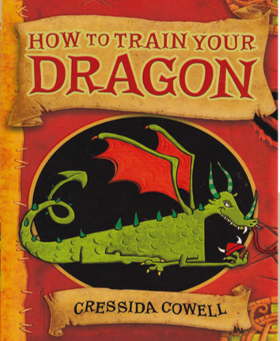

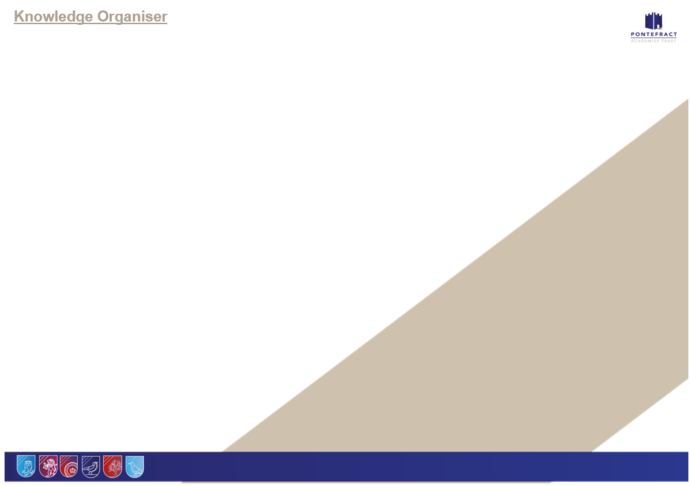

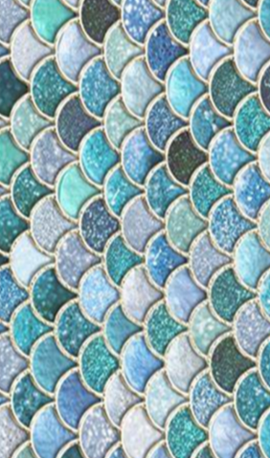
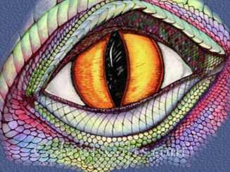
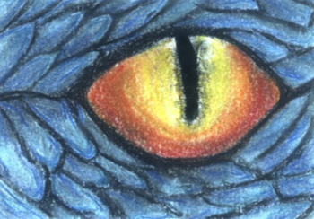
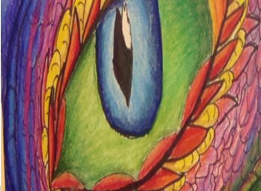
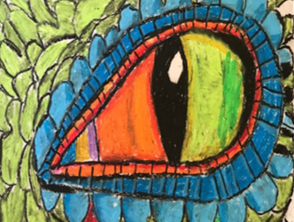
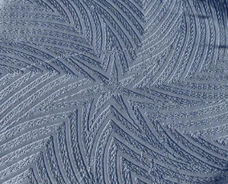
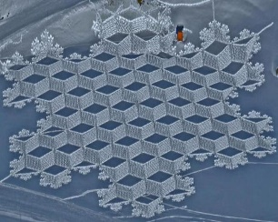
Fat Questions
Is a piece of art ever finished? How do you know when to stop?
Does writing, for example a novel, influence art or vice versa?

Fat Questions
Art can be created out of anything. Do you agree?
Is a piece of art ever finished? How do you know when to stop?
Can a piece of art be temporary?

