Spring Term Overview: ART

Spring Term Book – One Day On Our Blue Planet
Topic(s) – Layered textile ocean |  | Guide Time = 3 weeks
Assessment: | Year 1 and 2: Assessment of final piece against design criteria. Evaluate their final piece of art work.  Year 2: Constructively critique the work of their peers. | Very Important Points (VIPs):  - Fabric can be joined by gluing, sewing, or stapling.  - A running stitch is a stitch with an in-out pattern.  Fat Questions:  Is a piece of art ever finished? How do you know when to stop?  Are paints the only resource that can be used to make a piece of art?  How are materials used in everyday life?
Links to prior learning (sequencing) and canon book | Children are currently reading 'One Day on our Blue Planet' as their canon book which is based on Antarctic life. The book shows images of the ocean for children to use to support their learning and provide inspiration. Children may have limited experience of sewing and fabric skills – this is an introductory unit.
Links to other learning (cross fertilisation) | Thematic Questions  The World Beyond Us  Can art help us to understand the world beyond us?  What is sewing used for around the world?  Modern Britain  Are modern day artists respected as much as artists from the past?  How does art influence modern society?  How does ‘One Day on our Blue Planet’ link to British Values?  Healthy Bodies & Healthy Minds  How can art help our mental health?  How is fabric used to promote good health?  The World Around Us  Does where you live in the world have an impact on the type of art that you produce?  How do different pieces of art make you feel?  How is sewing used in our everyday lives?  Culture  Does it help us to look at other artist’s work or does it make it harder to produce our own work?  How are pieces of art different across the world?  Technology in Action  What technology do we have that would enable us to see the Antarctic from where we live?  Can a computer create a better piece of art than a human?  Can technology be used to produce art?
Links to future learning | Children will build on their running stitch skills in years 3, 4 and 5 where they will be work into a print using running stitch, complete a running stitch around a shape and learn how to do a backstitch and french knot.
Character/Wider Development ('50 things', cultural capital, skills) | As this is a new skill, children are likely to show a sense of curiosity and will develop their questioning skills.  In Year 2, children will discuss and evaluate the work of their peers, therefore learning skills of diplomacy and resilience.  Sewing and textile work requires concentration, resilience, and problem-solving skills.

OVERVIEW OF TEACHING SEQUENCE

Key Facts/Learning | Learning Focus or Key Question | Learning Outcomes (NC) | Key Words/  Vocabulary | Greater Depth/SEND | Misconceptions | Activities and Resources
Lesson 1  Children to complete a simple running stitch. This is a basic stitch with an in-out pattern. | L.O. To perform a running stitch. | To develop a wide range of art and design techniques in using colour, pattern, texture, line, shape, form, and space.  To use drawing, painting and sculpture to develop and share their ideas, experiences and imagination. | Needle, thread, sew, running stitch, fabric, point, knot, tangle, pull. | SEND  Children to be given a larger piece of material and larger plastic needle to complete a simple running stitch (with the support of an adult if necessary).  GD  The children are to be able to challenge themselves further. This may be by completing a running stitch of a shape or even their name. | Children may tangle their thread often.  Children may struggle to thread the material. | Begin by showing children a picture of a running stitch. Take feedback in order to gain children’s thoughts – Do they know what it is? Have they seen anyone doing this activity before? Are they able to identify and name some of the equipment?  Provide children with instructions/videos of what a running stitch is using the slides to support.  Discuss with children ways that we could create our own running stitch – Can you create a shape? Can you do a running stitch for the first initial of your name? Allow time for children to discuss.  As part of the process, the children will practise the technique of a running stitch. First, the teacher to demonstrate. Children experiment using the thread to create a running stitch.  Resources  - Material  - Thread  - Needles  - Scissors  Deepen the Moment  How is sewing used in everyday life?
Lesson 2  Creating a textile layered ocean. | L.O. To join two pieces of fabric together. | About the work of a range of artists, craft makers and designers, describing the differences and similarities between different practices and disciplines, and making links to their own work. | Needle, thread, sew, running stitch, fabric, material, point, knot, tangle, pull. | SEND  Provide fabrics with a loose thread structure to make it easier to pass the needle through. Alternatively, embroidery hoops can be used to add tension to the fabric and make it easier to hold and stitch.  GD  Children could experiment with adding beads onto their running stitch. | Children may tangle their thread often.  Children may struggle to thread the material.  Children may struggle to cut the material. | Recap Lesson 1’s learning – Evaluate what went well and what wasn’t successful. Who can remember what we need to complete a running stitch?  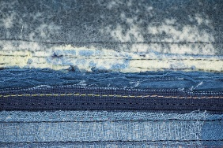  Children to cut a range of blue material to represent the ocean. Children can glue some of the material onto the aida fabric if needed and complete a running stitch on one piece of material. Give time for children to explore how to join fabrics before starting work on their final piece.  Resources  - Needles  - Aida fabric  - Blue material  - Thread  - Scissors  - Pencil  - Glue  - Beads  Deepen the Moment  Anything can be used to create Art. Do you agree or disagree?
Lesson 3 – Finishing and evaluation | LO: Joining two pieces of fabric. | About the work of a range of artists, craft makers and designers, describing the differences and similarities between different practices and disciplines, and making links to their own work. | Needle, thread, sew, running stitch, fabric, material, point, knot, tangle, pull, ocean, bead. | SEND  Provide fabrics with a loose thread structure to make it easier to pass the needle through. Alternatively, embroidery hoops can be used to add tension to the fabric and make it easier to hold and stitch.  Working larger scale can support some SEND children.  GD  Encourage GD children to use a range of thread colours and fabrics in their layered piece. They will be able to problem solve any issues with fabric thickness or tangling. | Children may not understand how to give feedback. Teacher to model this. | 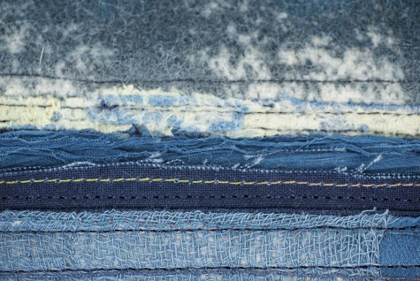  Starter- Children to look at a variety of ocean pictures. Discuss with their partners if they think they are real photographs or art work.  Children to finish their textile layered ocean. Can they add more detail? Add a bead to the thread?  Discuss ideas as a class and in small groups.  Children to finish their art if needed, applying fine details. Then, as a whole class, the children discuss and evaluate what they have done. Then, independently, the children will write a short sentence of their own evaluation.
Context (big picture learning)

Art enhances fine motor skills, hand-eye coordination, problem solving skills, lateral thinking, complex analysis and critical thinking skills.

