Spring Term Overview Years 3&4 – Computing
Spring Term Book(s) – How to Train Your Dragon
Topic(s) – Using a Variety of Software (Stop Motion)
Assessment: | Ongoing formative assessment of key knowledge and skills for each year group.  Using and applying unit in Term 6 | Very Important Points (VIPs):  - Coding is writing codes from one language to another.  - Programming is to program a machine or activity with a given set of instructions.  - A forever loop is a sequence of instructions that has no end.  - A repeat loop has a particular number of times that can be set.  - Coding is computing literacy that is important for the future.  - I don’t always have to use my mousepad to initiate code. I can use the keyboard.  (VIPs specific to software used)  Fat Question:  How has coding and programming contributed the world we live in today?
Links to prior learning (sequencing) and canon book | Year 3 children won’t have experienced coding during KS1 and so this will be new learning for them.  Year 4 children learnt about coding during Year 3, and used Turtle Logo to practice this. They will be able to apply their knowledge and key terminology when creating a new form of animation.
Links to other learning (cross fertilisation) | Links to Maths when creating regular polygons and angles. Links to literacy, writing and sequencing.
Links to future learning | Year 3 and Year 4 will encounter coding as they move through school and will look at it in more depth in UKS2. In Year 5 and 6, children will continue to use a variety of software and will be able to apply learning to new areas of Computing.
Character/Wider Development ('50 things', cultural capital, skills) | The World Beyond Us  Can learning about coding and programming give any insights into the future of technology?  Modern Britain  Where can we find evidence of coding and programming in the technology that we have today?  Healthy Bodies & Healthy Minds  How can we use coding and programming to promote mental and physical wellness?  The World Around Us  Is coding a universal language? If not should it be? Why?  Culture  Are all cultures as aware of the developments in coding and programming across the world?  Technology in Action  How is coding responsible for the technology that we rely on today?

OVERVIEW OF TEACHING SEQUENCE

Key Facts/Learning | Learning Focus or Key Question | Learning Outcomes (NC) | Key Words/  Vocabulary | Greater Depth/SEND | Misconceptions | Activities and Resources
Lesson 1 | LO: To learn how to draw with a pen on scratch. | NC Objectives for all lessons:  Children are responsible, competent, confident and creative users of information and communication technology  Children can select, use and combine a variety of software (including internet services) on a range of digital devices | Scratch  Command | GD:  Will be able to write their initials with the pen.  SEND:  Will be able to draw a square using a simple algorithm following a set of instructions. | Children may think that:  Children may miss out steps in the programming so the program will not function.  Coding is writing codes from one language to another whereas programming is to program a machine or activity with a given set of instructions. | Children will explore using the pen up and pen down function  Children will practice turning, starting with 90 degrees.  Children will learn how to duplicate blocks.  Children will be able to clear the screen using the space bar.  Children will be able to save their work.  Follow activity sheets. 1 star for SEND/BAR. 2 star for ARE. 3 star for GD.  Deepen the moment  Look at the final slide on the PowerPoint and solve the algorithms.
Lesson 2 | LO: To draw regular polygons on Scratch |  |  | GD: Make a range of algorithms for different regular polygons then try to create a pattern.  SEND: Create a regular pentagon to being with support from an adult. | Children may think that:  Children may miss out steps in the programming so the program will not function.  Coding is writing codes from one language to another whereas programming is to program a machine or activity with a given set of instructions. | Children will ‘trial and error’ with different algortithms to decide what works and what doesn’t.  Children will use the repeat block.  Follow activity sheets. 1 star for SEND/BAR. 2 star for ARE. 3 star for GD.  Deepen the moment  Look at the final slide on the PowerPoint and solve the algorithms.
Week 3 | LO: To draw patterns on Scratch |  | Repeat block  Patterns  Pen  Polygon  Variable value | GD:  Create your own pattern that changes colour throughout.  SEND: Create a simple shape with adult support and add a repeat block to create a pattern. | Children may think that:  Children may miss out steps in the programming so the program will not function.  Coding is writing codes from one language to another whereas programming is to program a machine or activity with a given set of instructions. | Children will recap and practice with the pen. They will then remind themselves of how to use a repeat block.  Children will complete the Activity sheets: 1 star for SEND/BAR. 2 star for ARE. 3 star for GD.  Deepen the moment  Look at the ‘Which Pattern?’ slide on the PowerPoint and solve the algorithms.
Context (big picture learning)
Technology has such a wide-ranging application and we believe it is important for our children to encounter as many of them as possible. We want to ignite interest in the subject and inspire a curiosity to find out more. Children will also look into the how machines and technology that we rely on so much, works and the process behind each function.
Folder name (Trust shared > Primaries > KS2 > Year 3/4 Planning > Cycle B > Spring 1 – How to Train Your Dragon > Computing)
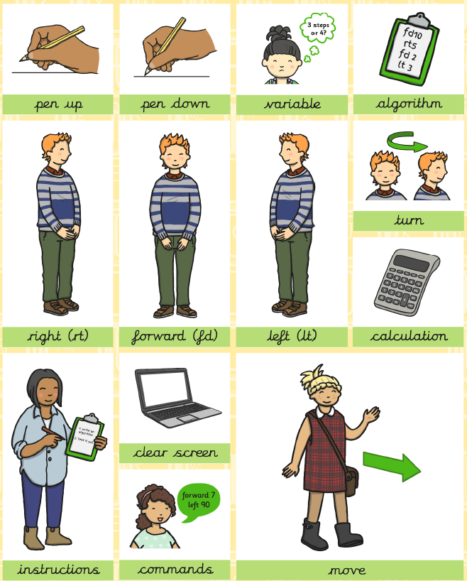
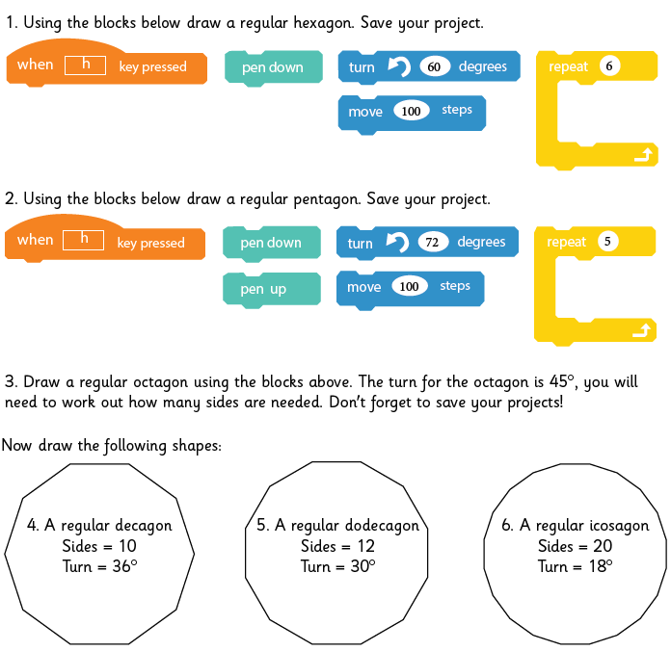
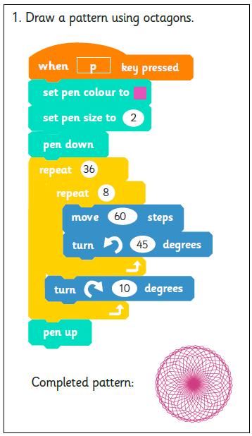
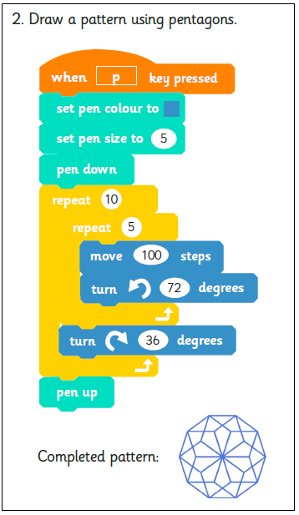
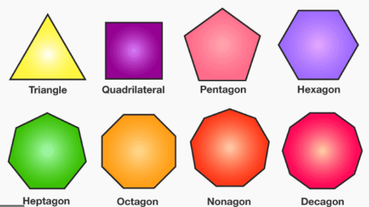
Knowledge Organiser

Key Vocabulary
Curriculum Intent:
Our Computing lessons are to prepare you for your future by giving you the opportunities to gain knowledge and develop skills that will equip you for an ever-changing digital world.

VIPs:
- Coding is writing codes from one language to another.
- Programming is to program a machine or activity with a given set of instructions.
- A regular polygon is a shape where all of the sides are the same length.
- An algorithm is a set of rules a computer program will follow.
- Coding is computing literacy that is important for the future.

FAT Question:
How has coding and programming contributed the world we live in today?

