Spring Term Overview Years 3/4 – DT

Spring Term Book(s) – How to Train Your Dragon
Topic(s) - |  | Guide Time = 3-4 hours
Assessment: | As well as work scrutiny, teachers are to make judgements based upon children’s ability to recall VIPs, and key knowledge.  VIP check at the end of the lesson. | Very Important Points (VIPs):  -A lever is a rigid arm that is braced against a turning point, or fulcrum. Pushing at one end of the arm creates a larger force at the other end.  - A lever is something that turns on a pivot  - A linkage is a system of levers connected by a pivot  - A mechanism is a collection of moving parts that work together  - A prototype is a model of the mechanism used for evaluation before creating the real product  Fat Questions: How have the uses of linkages and levers changed over time?
Links to prior learning (sequencing) and canon book | How to Train Your Dragon  Children to build on their knowledge from KS1, this will include  Designing purposeful, functional, appealing products for themselves and other users based on design criteria.  Select from and use a range of tools and equipment to perform practical tasks [for example, cutting, shaping, joining and finishing] Selecting from and use a wide range of materials and components, including construction materials
Links to other learning (cross fertilisation) | Science- Links to forces and magnets.  Art: Designing the face of the dragon using sketching techniques taught previously.  Maths: Measuring the equipment accurately using a ruler. Links to position and direction when talking about the rotation and movement of the puppet.  English: Links to our book 'How to train your dragon'.  RE: Links to Chinese New Year which will be celebrated on Friday 12th February 2021. We will look at the Chinese dragon and how this is included in the celebrations.
Links to future learning | This material will support children as they transition into UKS2.  It will support children in understanding how a lever and a linkage works. This can then be applied to other processes.
Character/Wider Development ('50 things', cultural capital, skills) | To create a dragon puppet with levers and linkages.  Thematic questions:  The world beyond us  How have linkages and levers helped to advance mechanisms in space?  Modern Britain  What linkages and levers do you come across in every day life?  What impact do linkages and levers have on mechanisms?  Healthy body, Healthy minds  How can linkages and levers be used to enhance fitness?  The world around us  Culture  How have linkages and levers contributed to religious festivals? Techology in action  How can linkages and levers advance technology?

OVERVIEW OF TEACHING SEQUENCE

Sequence | Learning Focus or Key Question | Learning Outcomes (NC) | Key Words/  Vocabulary | Greater Depth/SEND | Misconceptions | Activities and Resources
Lesson 1 | LO: To understand how things move using pivots, linkages and levers. | Understand and use mechanical systems in their products - for example, gears, pulleys,  Cams, levers and linkages. | lever  pivot  linkage  prototype  input  output  mechanism  design  split pins | GD: Extend knowledge by describing what a linkage and lever is and create a description.  SEND: Use the diagram and labels to identify the linkages and levers. | Children confusing the linkages and levers. | See slides and planning.  Resources: split pins, card, scissors, cardboard, paper, lollypop sticks  Y3 Tasks  Red: Children to label the diagrams to identify linkages and levers using the labels.  Blue: Children to use the diagram to label the linkages and leavers.  Gold: Draw a diagram of linkages and levers and label.  Children to then use given materials/equipment to use trial and error to work out which is the most reliable to create a linkage.  Y4 Tasks  Red: Children to label the diagrams to identify linkages and levers.  Blue: Children to use the diagram to label the linkages and leavers. Write a sentence to explain how they work.  Gold: Draw a diagram of linkages and levers and label. Children to then describe what a linkage and a lever is.  Children to then use given materials/equipment to use trial and error to work out which is the most reliable to create a linkage.  Deepening the moment  Can you think of a situation where mechanics have positively influenced the lives of people? Can you think of how they have negatively influenced?
Lesson 2  Design | LO: To design and create my prototype. | Understand and use mechanical systems in their products [for example, gears, pulleys,  cams, levers and linkages]  Generate, develop, model and communicate their ideas through discussion, annotated  sketches, cross-sectional and exploded diagrams, prototypes, pattern pieces and  computer-aided design | lever  pivot  linkage  prototype  input  output  mechanism  design  split pins | GD: Children to organise their own ideas when completing the design process. Children to also create a detailed description after creating their prototype.  SEND: Children to have a word bank with equipment, they can also add to this in the empty boxes. | -A prototype is the final product.  -Confusion between what a lever and linkage does. | See slides and planning.  Resources: split pins, card, scissors, cardboard, glue  Children to understand what a prototype is and the importance of them. Children to then design their dragon and label the materials that they will need. Ensure the materials required are available.  Year 3 Tasks  Red: Children to use the prototype sheet to design their dragon puppet. Identify the equipment that they will use using the given word bank. Children to then write a brief description of their product.  Blue: Children to use the prototype sheet to complete their design and describe their product.  Gold: Children to use the sub-headings to create their prototype and write a description of their design.  Year 4 Tasks  Red: Children to use the prototype sheet to design their dragon puppet. Identify the equipment that they will use using the given word bank. Children to then write a brief description of their product.  Blue: Children to use the prototype sheet to complete their design and describe their product. Evaluate what worked well and what needs to be improved for their final design.  Gold: Children to complete a design and description of their prototype in their books. Once completed, children to write an evaluation thinking about what worked well and what they will ensure is changed for next week.  Deepening the moment  Why would a prototype of a mobile phone be an important step for the development and selling process for a company like Apple?
Lesson 3  Make | LO: To use my prototype to create my dragon puppet. | Understand and use mechanical systems in their products [for example, gears, pulleys,  cams, levers and linkages]  Evaluate their ideas and products against their own design criteria and consider the  views of others to improve their work | lever  pivot  linkage  prototype  input  output  mechanism  design  split pins | GD: Children to give examples of how their puppet could be used in different contexts e.g. the teaching/telling of ‘How To Train Your Dragon’.  SEND: Children to use the given table to evaluate their design. Use the given word bank to help with this. | Confusion between what a lever and linkage does. | Resources: split pins, card, scissors, cardboard, glue, paper  Year 3 Tasks  Children to use their prototypes and designs to create their dragon puppet using levers and linkages. Children to then evaluate their products using the given templates.  Give opportunities to observe and evaluate their own and peers’ work.  Year 4 Tasks  Children to use their prototypes and designs to create their dragon puppet using levers and linkages. Children to then evaluate their products ensuring they are using subject specific vocabulary.  Give opportunities to observe and evaluate their own and peers’ work.  Deepening the moment  Can you think of three examples in school where we evaluate our work and why it is important not only in mechanisms?
Context (big picture learning)
Children will gain an understanding of the mechanical systems that are used in everyday life. They will be provided with the opportunity to identify examples of levers and linkages that they have in their houses, in school and in their local environment. They will understand the importance of a prototype and how by editing and improving their first design, their finished product will be of a much higher standard. Children will also will identify that prior learning plays an important role in understanding their progression of knowledge.

Folder name (Trust shared > Primaries > KS2 > Year 3/4 Planning > Cycle B > Spring 1 – How To Train Your Dragon > DT)
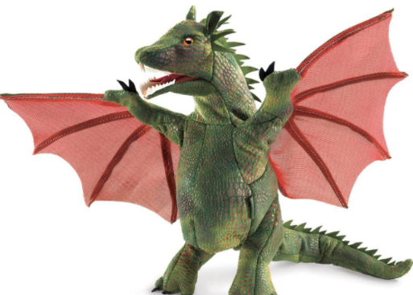
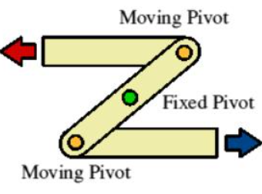
Key vocabulary
- lever
- pivot
- linkage
- prototype
- input
- output
- mechanism
- rigid
- fulcrum
- puppet
VIPS
-A lever is a rigid arm that is braced against a turning point, or fulcrum. Pushing at one end of the arm creates a larger force at the other end.
- A lever is something that turns on a pivot
- A linkage is a system of levers connected by a pivot
- A mechanism is a collection of moving parts that work together
- A prototype is a model of the mechanism used for evaluation before creating the real product

Learning intent
We will explore what levers and linkages are and how they work. We will experiment what are the best materials to use when creating linkages and levers. Then we will outline the importance of a prototype and allow time for the dragon puppet to be designed, made and evaluated. This links in extremely well to our book ‘How to Train Your Dragon’.

Linkage
Fat Question:
How have the uses of linkages and levers changed over time?

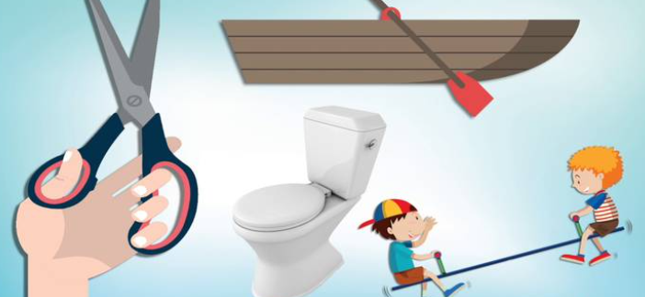
DT Knowledge Organiser

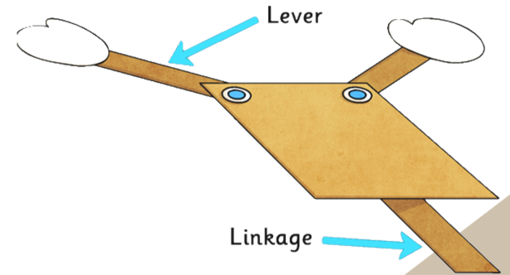
What is a lever?
A lever is a rigid arm that is braced against a turning point, or fulcrum. Pushing at one end of the arm creates a larger force at the other end.

