Spring Term Overview – DT

Spring Term Book – One Day On Our Blue Planet, Man On The Moon
Topic(s) - Design and make a moving lever scene |  | Guide Time = 6 weeks
Assessment: | Year 1: Design a product that uses a slider to show a scene from the canon book. Use a ruler to measure accurately. Evaluate the product by saying one positive and one improvement.  Year 2: Design a product that uses a slider to show a scene from the canon book. Use a ruler to measure accurately. Evaluate the product by saying two positives and two improvements.  As well as completed products and work scrutiny, teachers are to make judgements based upon children’s ability to recall VIPs, key knowledge and vocabulary. | Very Important Points (VIPs):  - Sliders make something move side to side or up and down.  - A slider needs a guide to hold it in place.  Fat Questions:  How are mechanisms/ sliders used in everyday life?  How and why are mechanisms/sliders used in children's books?  Why do you think sliders are called sliders?  How are sliders different to levers?
Links to prior learning (sequencing) and canon book | Children used cutting and measuring skills in the Autumn term as well as throughout their time in the Foundation Stage.  Children will have designed, made and evaluated 2 products in the Autumn term.  Children's designs link to the canon book as they recreate a scene from the book and decide which character will move.
Links to other learning (cross fertilisation) | Thematic questions:  The World Beyond Us  Do you think toys and books with moving mechanisms are more popular in rich or poor areas of the world? Why?  Modern Britain  Do you think toys with moving mechanisms are as popular as they used to be? Why?  Healthy Bodies & Healthy Minds  What should you do if your mechanism does not work?  Do we have any sliding parts on our bodies?  The World Around Us  Can you think of jobs that use sliding mechanisms?  Culture  How could a slider be used to make a card that celebrates someone’s religion?  Technology in Action  How could a toy with a moving mechanism, such as a slider, replace an electronic toy?
Links to future learning | This unit links to future work around forms of moving mechaniasms including the use of wheels.Children will continue to develop their understanding of mechanisms as they progress through KS2 where they will learn how to use and create electrical mechanisms. They will develop their design skills as they move through school and learn to think about function, appeal and purpose.
Character/Wider Development ('50 things', cultural capital, skills) | Children will continue to develop their resilience and pride. The children will learn to be critical towards themselves as well and others but, remaining respectful whilst doing so. Children will develop their evaluative skills being both critical and supportive of others. Children will learn how to take and apply constructive criticism.  50 Things  Put on a puppet show (LH) could incorporate the use of moving mechanisms.

OVERVIEW OF TEACHING SEQUENCE

Key Facts/Learning | Learning Focus or Key Question | Learning Outcomes (NC) | Key Words/  Vocabulary | Greater Depth/SEND | Misconceptions | Activities and Resources
Lesson 1 – Design a moving picture that uses a slider. | L.O: To design a sliding picture | NC  Design purposeful, functional appealing products for themselves and other users based on design criteria.  . | Moving  Mechanism  slider  Slot  Bridge  Guide  Assemble  Design  Make  Evaluate  Purpose  Audience | SEND –  To design a sliding picture with guidance and structure.  GD –  To consider whether a slider would more suited to the canon book if it went up and down or left and right. | Pupils may confuse what a slider is in everyday life.  Children may muddle up sliders and levers.  Children may over-complicate their designs. | Pupils to watch video about non-electronic moving toys. They are to explore how sliders work and discuss which they think work well and why.  Y2 to also consider where sliders can be found and how/why they are used in children’s books.  Y1- Pupils will design their moving picture and discuss the audience. They will draw and label the key components of their design with minimal support.  Y2- Pupils will design their moving picture and discuss the purpose and audience. They will draw and label the key components of their design independently.  Deepen the moment:  Do you think (non-electronic) toys with moving mechanisms are as popular as they used to be? Why?
Lesson 2-  Create the components of their sliding picture. | L.O: To create the components of a sliding picture. | NC Generate, develop, model and communicate their ideas through talking, drawing, templates, mock-ups.  Select from and use a range of tools and equipment to perform practical tasks.  Select from and use a wide range of materials and components, including construction and materials according to their characteristics. | Components  Moving  Mechanism  slider  Slot  Bridge  Guide  Assemble  Design  Make  Evaluate  Purpose  Audience | SEND-  To copy an image and character from the Blue Planet book. To have guidance on sizing and material choices where appropriate.  GD-  To evaluate if it would be possible to create a slider on a curved line. | Pupils may not create a character component of the correct size.  Pupils may over complicate designs leading to multiple moving parts.  Pupils may not measure or cut their bridge/slot effectively. | Pupils will refer back to their design sheets and recap their key learning and vocabulary. They will compile a list, as a class, of what components they think they will need. Children will discuss the audience of their product.  Y1- Pupils will use card to create a background scene and a character. They will plot the holes of their slot and choose a suitable holding component to attach to their character. Pupils may have copies of the book to copy from.  Y2- Pupils will use card to create a background scene and a character. They will plot the holes of their slot and choose a suitable holding component to attach to their character. Children will write about how their sliding picture will work and the components they have selected.  Deepen the moment:  Why might it not be appropriate to have multiple sliding parts on one image?
Lesson 3-  Construct and evaluate their sliding picture. | L.O: To make and evaluate a sliding picture. | NC Select from and use a range of tools and equipment to perform practical tasks.  Evaluate their ideas and products against design criteria. | Components  Moving  Mechanism  slider  Slot  Bridge  Guide  Assemble  Design  Make  Evaluate  Purpose  Audience  Modify  Improve  Criticism | SEND-  To construct and evaluate with guidance/support where necessary (cutting, punching, oral discussion, sentence copying).  GD-  To respond appropriately to constructive criticism. | Pupil may not make their levers to scale.  Pupil’s levers may not be measured equally.  Pupils may place split pins in incorrect places leading to their lever being  Unsuccessful, and not moving.  Pupils may think that because their lever moves it cannot be improved. | Pupils will refer to their design sheets and recap their key learning and vocabulary. They will discuss the audience of their product. They will compare their components and decide if any modifications need to be made. Children to watch teacher model construction of product including hole punching and slot cutting and discuss misconceptions. Children to recap steps they must make independently.  Y1- Pupils to punch holes and cut slots on background scene with support. Children to use tape or glue to attach their character to the ‘holding component (card strip or lollypop stick). Children to insert character into their slot and slide left/right or up/down. Children to evaluate their product against their success criteria, including one positive and one improvement.  Y2- Pupils to punch holes and cut slots on background scene with support. Children to use tape or glue to attach their character to the ‘holding component (card strip or lollypop stick). Children to insert character into their slot and slide left/right or up/down. Children to evaluate their product against their success criteria, including two positives and two improvements.  Deepen the moment:  Could you design and label a moving scene from another story book you know?
Context (big picture learning)
Children will be able to explain what a slider is and give an example of how they move. Children will be able to design, make and evaluate a product using their canon book. Children will use their knowledge of sliders to understand the world around them.

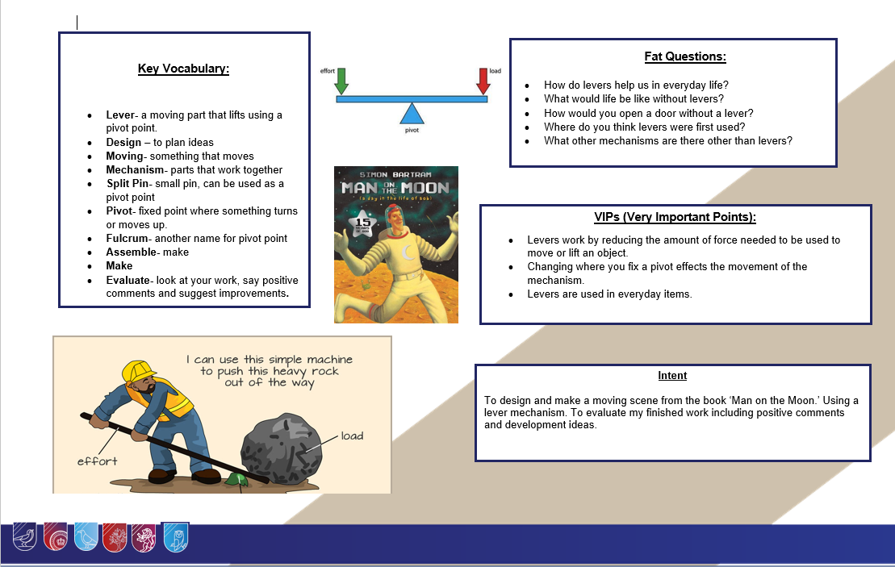

Knowledge Organiser DT

