Spring Term Overview Year 3 – Writing

Spring Term 3 Book(s) – How to Train your Dragon
Topic(s) – Myths and Legends (with a particular focus on using adverbs, prepositions and dialogue) |  | Guide Time = 3 weeks.
Assessment: | Teacher assessment using the statutory end of year assessment grids as a guide.  For this unit, there will be a focus on:  - Write effectively and coherently for different purposes  - Some use of paragraphs to group related material  - Using expanded noun phrases to describe and specify when describing settings and characters in narratives  - Some use of dialogue to show a character’s attitude  - Use of adverbs and prepositions to express time, place and cause  Using mostly correctly:  - Capital letters  - Full stops  - Question marks  - Exclamation marks  - Commas for lists  - Apostrophes for contraction  - Apostrophes to mark singular possession in nouns  - Some use of: inverted commas to punctuate direct speech  - Using the correct for of a/an mostly correct  - Spelling most words with contracted forms  - Adding prefixes and suffixes to spell most words correctly  - Some correct use of further homophones  - Spelling some words correctly from year 3 and 4 appendix 1 -statutory word list | Very Important Points (VIPs):  - Fiction writing is a story that is written about imaginary characters and events and not based on real people and facts  - The plot of a story is the events that take place.  - Myths are a traditional story-one that has lasted hundreds of years or more.  - Legends are a traditional story that may be based on some element of truth.  - Features of myths include; heroes/heroines, mythical beasts, magical items/powers, Gods & Godesses, multiple settings including heaven, earth and hell.  - Physical appearance refers to the way a person/character looks.  - Personality refers to the characteristics and qualities of a person/character.  - An expanded noun phrase consists of a determiner, adjectives and a noun.  - A determiner is a modifying word that determines the kind of reference a noun or noun group has, for example a, the, every.  - An adverb is a word that modifies an adjective or verb (in relation to time, manner or place).  - A simile is the comparison of one thing with another, e.g; "As brave as a lion."  - Inverted commas are the correct name for speech marks.  - Inverted commas should be used at the start and the end of direct speech.  - Alliteration is the occurance of the same letter or sound at the beginning of closely connected words, e.g; chattering chimpanzees.  - Prepositions tells us where something is.  - Adverbs of time tell us when something is happening.  - Said words are verbs that explain how a character says a line of dialogue in a story.  - Paragraphs are sections of text, used to structure writing to make it  clear and easy to read.  - Cursive handwriting is joined up handwriting.  - Pre-cursive handwriting is using the flicks on letters to aim to join eventually.  Fat Question:  How can dialogue enhance a reader's experience?  Are myths and legend stories based on real events? How do we know?  What would life be like if mythical beasts were a real thing?
Links to prior learning (sequencing) and canon book | How to Train Your Dragon (reading canon)  Children wrote a narrative story in Term 1 linked to the canon book 'The Firework Maker's Daughter'. They focussed on character and setting descriptions and will build upon this within this unit. They also learnt how to sequence a story and were beginning to think about their choice of vocabulary to interest a reader.  This unit will also build on skills introduced in Year 2:  - Narrative writing (including character and setting description).  - Writing for different purposes.  - Writing down ideas, including new vocabulary.  - Encapsulating what they want to say, sentence by sentence.
Links to other learning (cross fertilisation) | Children will be reading the canon book 'How to Train your Dragon' and learning about the Vikings in History.  Geography teaches vegetation belts such as forest, grassland, tundra, desert, and ice sheet which will link to different settings in mythical stories.  Art will also cross-fertilise learning around dragons and mythical beasts with pupils completing a dragon eye using oil pastels which links to character descriptions.  Reading for Purpose and Productivity lessons will also link to these areas of learning.  The World Beyond Us: How do Gods and Godesses link to planets and stars in Space?  Modern Britain: What would life be like in our country if mythical beasts existed nowadays?  Healthy Bodies & Healthy Minds: Would having a dragon for a pet be healthy for our bodies and mind?  The World Around Us: What mythical settings can be found in different countries around the world?  Culture: Why do some countries/cultures have famous myths and legend stories and others don't?  Technology in Action: Would it be possible to invent magical objects like flying shoes and a helmet that makes you invisible?
Links to future learning | Children will write an adventure narrative piece in the Summer Term based on the reading canon book, 'The Iron Man' to further develop the skills covered in this unit.  Throughout Year 3, children should start to become more aware of vocabulary choices and the impact this may have on the reader. They should be writing expanded noun phrases frequently and usind adverbs and prepostions to give more descriptive information to a reader.  Children should start to use inverted commas in the right place for dialogue sentences and some greater depth pupils will use other speech punctuation as well.
Character/Wider Development ('50 things', cultural capital, skills) | Evidence shows that reading narratives improves our vocabulary which can be applied not only in writing but to enhance speaking and listening.  Children will be exposed to a wide range of famous myth and legend stories such as Perseus and Medusa and Theseus and the Minotaur. This will widen their knowledge on Greek mythology. To enhance their learning on the Vikings they will read and learn about the mythical story of Thor. They will watch a short clip of a cartoon mythical story ‘The Saga of Biorn’ on an ageing Viking warrior who wishes to visit Viking heaven ‘Valhalla’ and develop the building blocks to be successful story writing by practising using a good balance of description and dialogue.  Children will gain a deeper understanding of how different authors have different styles for specific purposes.  Children will develop their understanding of stories that have been passed on through generations.  SLS library service can provide a range of fiction and non-fictions books to supplement the pupil’s learning.

OVERVIEW OF TEACHING SEQUENCE

Key Facts/Learning | Learning Focus or Key Question | Learning Outcomes (NC) | Key Words/  Vocabulary | Greater Depth/SEND | Misconceptions | Activities and Resources
Phase 1:  Reading and analysing  (approx. 3 lessons) | To understand and identify the features of a mythical story.  To read and learn about traditional myth stories.  To understand what makes a narrative story effective. | Ask relevant questions to extend their understanding and knowledge.  Use relevant strategies to build their vocabulary.  Checking that the text makes sense to them, discussing their understanding and explaining the meaning of words in context.  Develop positive attitudes to reading, and an understanding of what they read, by:  Listening to and discussing a wide range of fiction  Reading for a range of purposes | Y3/4 Statutory spelling list word mats.  Narrative.  Features.  Expanded noun phrase.  Conjunction.  Adjective.  Simile.  Alliteration.  Direct speech.  Paragraphs.  Preposition.  Adverb.  Adverb of time.  Myth  Legend  Hero  Monster  Plot | GD:  Have access to WAGOLLs that have more challenging vocabulary in them.  Compare and justify different WAGOLLs.  Challenge them to improve vocabulary choices in WAGOLL examples.  SEND:  Use texts with language that is accessible for their reading ability and / or linked to their targets. | A narrative story always has to have a happy ending.  A narrative story should be full of description and no dialogue.  An adverb always ends in ly. | To understand and identify the features of a mythical story  Read several WAGOLLs of mythical stories (Perseus and Medusa, Theseus and the Minotaur, Thor and his mighty hammer) and discuss what specific features are in a mythical story (hero, beast, Gods, magical powers/objects, different settings on heaven, earth and hell) as well as the features that make up a narrative story (expanded noun phrases, fronted adverbials, verbs/adverbs, conjunctions, punctuation choice and a good balance of description and dialogue).  Deepen the moment:  Give personal opinions on which mythical WAGOLL children prefer and why.  What makes a mythical story different to an adventure story?  Can you spot any prepositions and adverbs showing time in the WAGOLL examples.
Phase 2: Creation of hero and mythical beast character descriptions.  Identifying prepositions and adverbs of time in sentences.  Putting inverted commas in the right place.  Getting a balance of description and dialogue in narrative. Ensuring dialogue has inverted commas in the right place, a good range of said words and some adverbs.  (approx. 5 lessons) | To create a hero/heroine character and describe both physical appearance and personality traits.  To create a mythical beast character and describe both physical appearance and personality traits.  To recognise prepositions and adverbs of time in sentences.  To use inverted commas in the right place.  To write sections of a narrative story using a balance of description and dialogue with inverted commas, said words and adverbs.  . | Using adjectives, expanded noun phrases and similes for effect.  Choosing nouns or pronouns appropriately for clarity and cohesion and to avoid repetition.  Using conjunctions, adverbs and prepositions to express time and cause.  In narratives, creating settings, characters and plots.  Punctuating direct speech with inverted commas in the right place. | Y3/4 Statutory spelling list word mats.  Effective.  Appropriate.  Physical appearance.  Personality.  Describe.  Expanded noun phrase.  Conjunction.  Preposition  Adjective.  Simile.  Alliteration.  Dialogue.  Inverted comma. | GD:  Children should start to become more aware of vocabulary choices and the impact this may have on the reader. Children will confidently know where to put inverted commas in sentences. They may use other speech punctuation and a range of said words and adverbs.  SEND:  Children should be able to experiment using different types of figurative writing with mixed success. Further resources and scaffolding will be provided including word banks. | When describing characters it is ok to have one long list of adjectives in a sentence.  Dialogue can just be written all bunched together in one paragraph.  It doesn’t matter where you put the inverted commas in dialogue.  Said is the best verb to use when writing dialogue.  An adverb always ends in ly. | To create a hero character and describe both physical appearance and personality traits:  Discuss the hero characters from the three WAGOLLs. What qualities did they have in common? Draw a hero character and mind map, mood board or somehow describe physical appearance and personality traits. Put this writing into a paragraph using expanded noun phrases, similes and alliteration.  To create a mythical beast character and describe both physical appearance and personality traits:  Discuss the mythical beast characters from the three WAGOLLs. What qualities did they have in common? Discuss the dragons from the canon book. Draw a beast dragon character and mind map, mood board or somehow describe physical appearance and personality traits. Put this writing into a paragraph using expanded noun phrases, similes and alliteration. Use powerful verbs and adverbs for effect to show movement.  To recognise prepositions and adverbs of time in sentences:  Discuss different prepositions children know. Re-cap the job of an adverb. Do all adverbs end in ly? No. Share various sentences linked to the canon book. Children to copy them out and underline the preposition in each one. Discuss the job of an adverb of time. Share various sentences linked to the canon book. Children to copy them out and underline the adverb of time in each one. Challenge children to create a word bank of prepositions and adverbs of time that they could use in their own mythical story. Children to practise writing sentences using them.  To use inverted commas in the right place.  Discuss the role dialogue plays in a story. Discuss how much dialogue should be used in a story compared to description. Discuss inverted commas as a type of punctuation.  Display dialogue sentences from the canon book. Children to add in inverted commas in the right place. Children to create their own dialogue sentences for characters speaking from the canon book. Create a word bank of said words for children to use tomorrow.  To write a section of a mythical story using a balance of description and dialogue with inverted commas, said words and adverbs.  Introduce the short film ‘The Saga of Bjorn’ from the Literacy Shed website or YouTube.  The Saga of Biorn  Discuss what makes this film a mythical story. What features can they identify similar to the WAGOLLs that were read at the start of the unit?  Re-cap with children what dialogue is and how it should be presented. Ask if there is any dialogue in the Bjorn film? No. Explain today we are going to write the middle section of the story where Bjorn meets his opponents and create dialogue conversations between them. Model good dialogue sentences (inverted commas, speech punctuation, said words, adverbs and speech on a new line). Example “Victory is mine!” exclaimed Bjorn proudly. Also model shorter dialogue sentences that are short, snappy and don’t use the longer model each time.  Deepen the moment:  The hero of a story always has to be male.  Explain if you agree or disagree with this statement and justify your answer.  The razor-sharp sword plunged deep inside the dragon’s chest like a hot knife going into butter. Where is the simile in this sentence? How effective is this simile? Justify your answer in full.  Any preposition can be used in a sentence and it will still make sense. Prove this statement is wrong with examples.  What is the effect if a story is just full of dialogue and no description?  How could a mythical story have an ending that wasn’t happy?
Phase 3:  Plan and write.  (approx. 4 lessons) | To plan the sequence of events (plot) for my mythical narrative.  To write the first draft of my introduction.  To write the first draft of my build-up.  To write the first draft of my dilemma.  To write the first draft of my resolution. | Plan their writing by:  discussing writing similar to that which they are planning to write in order to understand and learn from its structure, vocabulary and grammar  Discussing and recording ideas  Draft and write by: composing and rehearsing sentences orally (including dialogue), progressively building a varied and rich vocabulary and an increasing range of sentence structures.  Organising paragraphs around a theme.  Using inverted commas in the right place. | Structure.  Plot.  Sequence.  Introduction.  Build-up.  Dilemma.  Resolution.  Dialogue  Inverted comma  Conjunction  Expanded noun phrase  Adverb of time  Preposition | GD:  Children ensure they have achieved all of the identified features. GD peer coaching to challenge and improve each other’s plans. Children will begin to use other speech punctuation with dialogue.  SEND:  Children use word banks to support them.  Possible use of small group planning to enable discussion of ideas as support. | Inverted commas go around the whole speech sentence including the said word and character’s name.  Quantity is more important than quality with story writing.  A story should be full of description and no dialogue.  Reading your writing back is a waste of valuable writing time.  My partner can’t help me as their story is different to mine.  It is ok to switch between the third and first person when writing a story. | To plan the sequence of events (plot) for my mythical narrative:  Re-cap children’s created heroes and mythical dragon beasts from earlier in the unit. Using a story mountain board, briefly plan the introduction, build-up, dilemma and resolution writing key vocabulary for each section. Create a word bank of adjectives, verbs, similes and prepositions/adverbs of time that could be used. Explain they are writing a mythical story similar to the canon book we are reading involving a dragon in the third person as if they are the narrator.  To write the first draft of my introduction:  Re-cap the introduction of the WAGOLL stories looked at in this unit. Discuss what makes an introduction effective-a good amount of description of the main character and setting. Write the first draft following steps to success focusing on adjectives, expanded noun phrases and similes.  To write the first draft of my build up:  Re-cap the build-up of the WAGOLL stories looked at in this unit. Discuss what makes an effective build-up- dialogue and description with tension building. Write the first draft following steps to success focusing in particular on dialogue ensuring inverted commas go in the right place.  To write the first draft of my dilemma:  Re-cap the dilemma of the WAGOLL stories looked at in this unit. Discuss what makes an effective dilemma- a difficult and dangerous situation for the hero to over-come with often a battle scene. Write the first draft following steps to success focussing on prepositions and adverbs of time.  To write the first draft of my resolution:  Re-cap the resolution of the WAGOLL stories looked at in this unit. Discuss what makes an effective resolution- a happy or sad ending where the beast is overcome usually. Write the first draft following steps to success focussing on using a range of punctuation including apostrophes for possession.  Deepen the moment:  How could I have ended my story differently? Suggest 2 different resolutions briefly.  SPaG spotting. Identify a good example of an adjective, verb, preposition, conjunction, adverb of time, simile and apostrophe for possession in my writing.  Use a thesaurus to change vocabulary to make it even more powerful.  Use a dictionary to check and change your own spellings.
Phase 4:  Edit and improve.  (approx. 1 lesson) | To edit each paragraph of my mythical narrative. | Evaluate and edit by: assessing the effectiveness of their own and others’ writing and suggesting improvements.  Proposing changes to grammar and vocabulary to improve consistency, including the accurate use of pronouns in sentences.  Proofread for spelling and punctuation errors. | Y3/4 Statutory spelling list word mats.  Improve.  Edit.  Alternative.  Appropriate.  Effective.  Analyse.  Evaluate.  Strengths.  Weaknesses.  Peer check.  Self check. | GD:  Children expected to use resources such as word banks, dictionaries and thesaurus to improve their own vocabulary.  SEND: Ensure that SEND children spend a suitable amount of time editing ‘the basics’ such as full stops, capital letters using adjectives and conjunctions. | First drafts should be perfect.  There are not any mistakes in my first draft because I cannot find any.  Proof reading means reading through my work quickly. | To edit each paragraph of my mythical story.  Using the editing stations, edit each paragraph of my story using a variety of peer coaching.  Deepen the moment:  Identify where you could edit and improve sentences.  What is wrong with it?  How could you make it better?  Use a thesaurus to improve vocabulary choices.  How many different ‘said’ verbs can you think of?  Can you change one of your adverbs of time to be used at the begin of your sentence?
Phase 5:  Publishing and presenting.  (approx. 1 lesson) | To write the final draft of my narrative mythical story in a neat cursive or pre-cursive style. | Read their own writing aloud, to a peer, adult or the whole class, using appropriate intonation and controlling the tone and volume so that the meaning is clear.  Use the diagonal and horizontal strokes that are needed to join letters and understand which letters, when adjacent to one another, are best left unjoined  Increase the legibility, consistency and quality of their handwriting | Y3/4 Statutory spelling list word mats.  Presentation.  Handwriting.  Cursive.  Pre-cursive. | GD:  Continue to edit and improve their writing as publishing.  SEND: Ensure correct letter formation and pre- cursive handwriting. | Capital letters can be joined to lowercase letters.  Handwriting can be of any size.  Letters can be as close together as I want. | To write the final version of my narrative:  Write the final draft after self-checking and peer-checking success criteria has been met and mistakes have been rectified.  Use cursive style handwriting to publish writing.  Deepen the moment:  Which letters do I need more practise joining with my cursive style? Practise them in handwriting books.
Context (big picture learning):
Children will use the reading canon book, How to train your dragon as a basis to write a narrative using a variety of writing techniques including adjectives, expanded noun phrases, similes, adverbs, prepositions, adverbs of time, paragraphs, alliteration and direct speech. They will use figurative language and a range of punctuation to describe their created characters appropriately and effectively throughout their clearly structured narrative. Children will become more confident with structuring dialogue sentences effectively using inverted commas in the right place and start to get the balance right between description and dialogue in their writing.

Folder name (Trust shared > Primaries > KS2 > Year 3/4 Planning > Cycle B > Spring 1 – How to train your dragon > English)

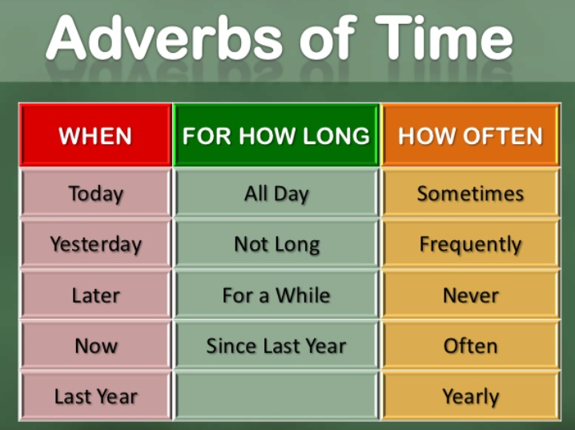
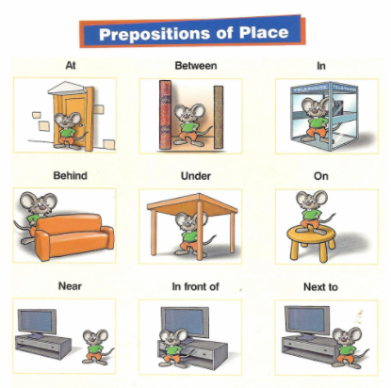
Year 3 Writing Knowledge Organiser (Myths and Legends)

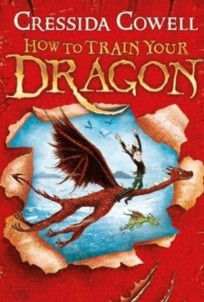
Key Vocabulary:
Adjective – describes a noun
Expanded noun phrase – tells you more about a noun Adverb – describes a verb
Appearance – what a person looks like
Personality – the character and nature of a person
Plot – the main events of a narrative (what happens)
Sequence – the order events in a narrative take place
Setting – the location in which a story takes place
Simile – used to describe something by comparing it to something else
Structure – the overall layout of a story
Alliteration - the repetition of the same beginning sound of words
Cohesion – linking sentences and paragraphs meaningfully to ensure it flows.
Conjunction- joining word
Prepositions- tell us where something is.
Adverbs of time-tell us when something is happening.
Inverted commas- are speech marks " "

Writing dialogue:
Recognise what is being said and ensure to use to use inverted commas around it.
“Let’s see what pathetic creature Hiccup has got,” said Snotlout.
Your inverted commas need to be around the actual words that are being spoken and you must include other speech punctuation inside the inverted commas (commas, question marks or exclamation marks).
Change the position of the dialogue in the sentence.
Snotlout said, “Let’s see what pathetic creature Hiccup has got.”
Use a variety of ‘said words’ to make the dialogue interesting (shouted, exclaimed, asked, demanded, whispered).
Use adverbs to support the ‘said words’ (proudly, happily, angrily).
“Let’s see what pathetic creature Hiccup has got,” declared Snotlout sarcastically.
Use short snappy dialogue sentences at times as well.

Learning intent:
We will use How to Train Your Dragon as a basis for writing a mythical narrative using a variety of techniques drawing on our year 2 learning. We will be focusing on vocabulary choices and the impact this has on the reader in particular expanded noun phrases, verbs and similes. We will develop our skills of using inverted commas in the right place with dialogue. We will recognise and use prepositions and adverbs of time in our writing.

