Spring Term 3 Overview Year – English

Term 3 Book(s) – How to Train Your Dragon
Topic(s) – Newspaper Report |  | Guide Time = 3 weeks
Assessment: | Final published newspaper report about a theme of schools choice linked to the reading canon book. .  Half termly SPaG assessment and termly reading paper.  Use the statutory end of year assessment grids.  - Write for a range of purposes and audiences, showing awareness of the reader.  - Selecting language that shows good awareness of the reader.  - Use paragraphs as a presentational devices to structure their writing.  - Use a range of sentence structures to show a good awareness of the text type.  - Use a wider range of subordinating conjunctions across sentences.  - To punctuate more complex sentences correctly  - Use simple devices to structure the writing.  - Using fronted adverbials to emphasise the adverbial to the reader.  - Use inverted commas to punctuate direct speech.  - Effectively use reported speech to show awareness of the text type – a newspaper. | Very Important Points (VIPs):  - Newspapers have a name which is at the top of the paper.  - A headline is eye-catching, short and normally a pun to draw the reader in.  - Alliteration is often used in headlines or sub-headings to catch the readers attention.  - Introductory paragraph that includes that five Ws.  - Pictures are used which have a caption underneath.  - Facts need to be truthful.  - Written in third person and past tense.  - Quotes are written as direct speech using inverted commas.  - Reported speech does not need inverted commas and is used widely in newspaper reports.  - A concluding paragraph to summarise main points.  - There are two types of newspapers in the United Kingdom; broadsheets and tabloids.  Fat Questions:  Is a newspaper report an old fashioned source of information?  Could society function without getting news from newspapers?
Links to prior learning (sequencing) | Children will build on their KS1 SPaG skills throughout this topic and will also draw upon the skills learnt in Autumn 2 when they have written an explanation text.  This unit will build on  - Writing for different purposes.  - Writing down ideas including new vocabulary.  - Making simple additions, revisions and corrections to their work.
Links to other learning (cross fertilisation) | Links to Geography - Biomes and vegetation belts  Links to Science – Forces and Magnets  Links to canon book for Spring 1: How to Train Your Dragon.
Links to future learning | Using the skills taught in this unit, the children will complete a set of descriptive insructions in summer 1. They will also be able to apply their learning to a balanced argument in Summer 2.  This learning will support children when they move onto further learning on non-chronolgical reports, a more in depth newspaper report and instructional writing in UKS2 and will provide them with exposure to a variety of text types.
Character/Wider Development ('50 things', cultural capital, skills) | Evidence that reading non-fiction texts increases reading achievement.  A deeper understanding of how events which happen without us seeing them have an impact on our daily lives.  Understanding of how non-fiction provides information and can be written in different forms i.e. newspapers (cultural capital).  SLS library service can provide a range of fiction and non-fictions books to supplement the pupil’s learning.  The World Beyond Us: How might newspaper reports change within the next 100 years? Will they still be relevant? Why? Why not?  Modern Britain: How sustainable is printing millions of newspapers a year on our environment? Why is this important?  Healthy Bodies & Healthy Minds: What is the impact of negative reports on our mental health?  The World Around Us: How do other countries ensure newspaper reports are issued to the public?  Culture: Can writing about culture and religious beliefs be damaging to society?  Technology in Action: Why do we need newspaper reports when everything can be found online?

OVERVIEW OF TEACHING SEQUENCE

Key Facts/Learning | Learning Focus or Key Question | Learning Outcomes (NC) | Key Words/  Vocabulary | Greater Depth/SEND | Misconceptions | Activities and Resources
Phase 1:  Reading and analysing  (Suggested 1 lesson) | To identify the key features of a newspaper report. | Identifying how language, structure and presentation contributes to meaning.  Retrieve and record information from non-fiction.  Ask relevant questions to extend their understanding and knowledge.  Use relevant strategies to build their vocabulary.  Checking that the text makes sense to them, discussing their understanding and explaining the meaning of words in context. | Main title  Headline  Paragraphs  Photos  Captions  Facts  Evidence  Formal language  Y3/4 statutory spellings | GD:  To identify a range of features independently across more than one text. Have access to texts which have more challenging vocabulary and structures.  SEND: Children to have a list of features to identify in the text. Text accessible for reading ability with adult reading support where necessary. Allow children to discuss as a group as opposed to writing using A3 examples. Take a photo for evidence in books. | Children may think that:  Newspaper reports are fiction.  The headline is the same as a sub heading.  The headline is the same as a title. | To identify the key features of a newspaper report.  Read several differentiated WAGOLL Newspaper reports (range of themes) and discuss what a newspaper report is, identifying its key text features.  Use differentiated WAGOLLs to identify and underline each key feature to make children familiar with a newspaper report content.  Deepening the moment  Would a newspaper report without a headline be as effective in catching the reader’s attention?
Phase 2  To practise elements of a text.  (Suggested 4 newspaper related SPaG lessons) | To use subordinating clauses. | Using conjunctions, and prepositions to express time and cause.  Composing and rehearsing sentences orally (including dialogue), progressively building a varied and rich vocabulary and an increasing range of sentence structures | Clause  Subordination  Fronted adverbial  Comma  Subject  Verb  Conjunction  Y3/4 statutory spellings | GD: Children practise independent subordinating clauses at the beginning, middle and end of sentences, punctuating properly with commas.  SEND: Use cut up sentences so that children can manipulate the sentence structure and order to identify what makes sense. Focus just on fronted adverbials. | Subordinating clauses can only come at one point in a sentence  A subordinating clause has to have a comma. | To use subordinating clauses  Use example newspaper reports to identify subordinating clauses.  Explain that a subordinate clause is a clause that cannot stand alone as a complete sentence but is linked to the main clause using a subordinating conjunction.  Explain that a subordinating clause can come at different points in a sentence. (Beginning as a fronted adverbial, middle and end)  Explain the general rules for using commas depending on where the subordinating clause is in a sentence.  Allow children to apply their understanding in differentiated tasks.  Deepening the moment:  A subordinate clause must have a comma. Do you agree or disagree? Try and use examples to justify your answer.
 | To understand and use direct speech. | Using and punctuating direct speech. | Inverted commas  Direct speech,  Quotations  Verbs  Commas  Exclamation marks  Question marks  Punctuation | GD: Children to create independent sentences and ensure they use a variety of position for the quotations. Encourage variety of synonyms for said.  SEND: Physical sentences for manipulation to help with the correct positioning of punctuation and sentence order. | That inverted commas are simply placed at the start and end of a sentence.  Written speech must come at the start of a sentence. | To understand and use direct speech.  Children need to understand the purpose of direct speech and the impact it has on the reader in a newspaper report.  Once this has been taught, children need to be shown the correct way to punctuate direct speech and be introduced to different synonyms for said.  Differentiated tasks to allow children to apply their understanding not only of positioning of punctuation but content of sentences.  Deepening the moment  True or False. When using speech, it has to come at the beginning of the sentence.
 | To understand and use reported speech | Composing and rehearsing sentences orally (including dialogue), progressively building a varied and rich vocabulary and an increasing range of sentence structures | Reported speech  Indirect  Commas  Exclamation marks  Question marks  Punctuation | GD:  Children create independent sentences using their knowledge of subordinate clauses to help them structure their sentences.  SEND: Children sort examples of direct and reported speech, discussing how they know the differences. | Children may think that reported speech needs inverted commas.  Children may think that reported speech is not a quote. | To understand and use reported speech.  Recap on direct speech from previous lesson and then show the difference between direct and reported speech.  Children need to understand the purpose of reported speech and the impact it has on the reader in a newspaper report. Once this has been taught, children need to be shown the correct way to punctuate reported speech (no inverted commas).  Differentiated tasks to allow children to apply their understanding.  Deepening the moment  Reported speech is usually written in what tense? The past or the present? Why?
 | To create headlines using alliteration, puns and rhyme. | Headings and sub-headings to aid presentation | Y3/4 statutory spellings | GD:  Challenge children to use all 3 techniques (alliteration, rhyme and pun) in their headline.  SEND: Give children examples of ready made headlines and ask them to discuss which they think is the best and why.  Provide headlines with missing words for children to complete. | Children may struggle to think of rhyming words and so choose any word that does not make sense in the sentence  Every word in an alliterative sentence has to start with the same sound | To create headlines using alliteration, puns and rhyme.  Explain that the most effective newspaper reports begin with an eye catching headline.  Using WAGOLL headlines, explain the techniques of alliteration, rhymes and puns and how we can use these to create humour and excitement in our writing.  Allow children to experiment with the different techniques and have a go at creating headlines.  Deepening the moment  Annie says that every word in an alliterative sentence must begin with the same letter/ sound. Is Annie correct?
Phase 3  Collecting and organising information.  (Suggested 1/2 lessons) | To use the 5 Ws to collect and organise information. | To plan their writing by discussing and recording ideas. | Y3/4 statutory spellings.  Adverbials  Reported speech  Direct speech  Quotation  Pronoun  Openers  Headlines  Pictures  Captions  5 Ws | GD: Use all 5 W words when collecting information. Notes to include more precise, technical in detail and higher level vocabulary.  SEND: Children to take notes from a range of differentiated texts which they can access. Children to work in groups and use iPads as extra support. | Notes have to be full / detailed sentences.  They can just copy full chunks of writing without understanding the content. | To use the 5 Ws to collect information.  Introduce the 5 Ws to children. (Who, what, why, where, when) Discuss why these headings will be useful when planning our newspaper reports.  Using prior learning, WAGOLLs, books and the computer children are to conduct their own research about the theme of their newspaper report. Could provide children with post it notes and a planning sheet to organise each note they take under the correct heading.  Model how to effectively research and take notes with children, discuss the use of reliable sources and how children must understand what note they are taking as this will be needed for when they write their own report.  Deepening the moment  Explain why the 5 Ws are important to include in the introduction of a newspaper report.
Phase 4  Planning  (1 lesson) | To plan a newspaper report. | Plan their writing by discussing writing similar to that which they are planning to write in order to understand and learn from its structure, vocabulary and grammar. | Main title  Headline Paragraphs  Photos  Captions  Facts  Evidence  Formal language  Y3/4 statutory spellings | GD:  Children create their own planning format to record notes on.  Plan in detail with several sub-headings.  .  SEN: Scaffold provided. Subheading prompts given to aid their structure. Word bank provided. | Children may think they have to write the full paragraphs instead of using note forms. | To plan my newspaper report.  Children to use their W word notes from the previous session to plan their work using a provided planning sheet.  Children will be given a differentiated planning sheet to map out their ideas.  Deepening the moment  When planning, you need to ensure you write in full sentences. Do you agree? Why? Why not?
Phase 5  To create a draft  (2 lessons) | To write a first draft of our newspaper report. | Draft and write by organising paragraphs around a theme.  Draft and write by using simple organisational devices in non-narrative material.  Draft and write by composing and rehearsing sentences orally, progressively building a varied and rich vocabulary and an increasing range of sentence structures. | Y3/4 statutory spellings | GD  Use a full range of features confidently and consistently with increased accuracy in all paragraphs. Show cohesion between paragraphs and clear organisation  SEND: Word mats to support. Rehearse sentences orally before writing into their books. | Children copying straight from the planning without making into full sentences.  Children may copy from WAGOLLs or straight from working walls without considering what they are writing. | To write a first draft of a newspaper report.  Recap WAGOLLs with the children and look at the different features and structure of the newspaper report. Put this on the working wall for children to see clearly. Children to the continue writing their paragraphs to for their first draft.  Break the writing down into manageable chunks for children. E.g. Headline and introduction on day one and then next two paragraphs on day two. Model each section, reminding children of the techniques they have practised such as subordinating clauses and speech.  Ensure children know clearly the breakdown of the lesson, often children will continue writing without checking their work throughout the lesson, allow adequate time for stopping.  Deepening the moment  Ben thinks he doesn’t need to try that hard on his first draft as he has to do it all again for this final piece anyway. Do you agree with him?
Phase 5  Edit and improve  (2 lessons) | To edit and improve my newspaper report. | Evaluate and edit by assessing the effectiveness of their own and others writing and suggesting improvements.  Propose changes to grammar and vocabulary to improve consistency.  Proof read for spelling and punctuation errors. | Y3/4 statutory spellings  Adjective  Paragraph  Conjunction  Compound  Complex  Structure  Features  Reported speech  Punctuation  Direct speech  Inverted commas | GD:  Create their own assessment criteria check lists to use when checking their work.  Act as ‘teacher’ for LA children, marking and up levelling their work.  SEND:  Ensure that SEND children spent a suitable amount of time editing ‘the basics’ – sentence structure and basic SPAG elements.  Provide scaffolding prompts to help with this such as a SPAG reminder resource.  Copy examples from children’s books and work as a group to find the areas for improvement. | That their work is already good enough and they don’t need to make any changes.  Editing just means checking for capital letters and full stops.  The only editing I need to make is from the marking my teacher has done.  Children may edit in mistakes. | To edit and improve my draft.  Use a variety of peer coaching to edit and improve their narrative (At this stage focus on punctuation, spelling of key words and correct use of skills taught throughout sequence of learning).  Show examples of children’s work (both strong examples and those that could be improved and discuss how we can use our editing skills to make improvements)  Deepening the moment  Child as teacher. Provide a sentence from a peer’s newspaper report for them to mark and improve.
Phase 6:  Publish and present  (3 lessons) | To write my final newspaper report. | Read aloud their own writing to the whole class showing appropriate intonation and controlling the tone and volume so the meaning is clear.  Increase the legibility, consistency and quality of their handwriting. | Y3/4 statutory spellings  Adjective  Paragraph  Conjunction  Compound  Complex  Simple  Reported speech  Punctuation  Direct speech,  Inverted commas | GD: Opportunity given to use a laptop to present work.  SEND: Word banks, reminders for cursive and correct letter formation. |  | To write my final newspaper report.  After children have edited and improved their work to create a final draft they are to publish their final copy of their newspaper report.  Children should be encouraged to use the correct structure of a newspaper report and some/all children given opportunity to type up on a laptop.  Deepening the moment  Which feature do you think you have used most effectively in your newspaper report?

Context (big picture learning)
Children will know the key features of a newspaper report and identify these on different WAGOLLS. From this, children will be able to apply their understanding to the key SPaG features of a newspaper report and use them explicitly. They will use research methods to effectively gather information before putting into a concise plan. Building on prior learning, children will use their planning and notes to write their first draft. After this, children will use editing stations to carefully and succinctly make adaptations to improve their work. Finally, they will publish their final piece.

V.I.Ps
- Newspapers have a name which is at the top of the papaer.
- A headline is eye-catching, short and normally a pun to draw the reader in.
- Alliteration is often used in headlines or sub-headings to catch the readers attention.
- Introductory paragraphy that includes that five Ws.
- Pictures are used which have a caption underneath.
- Facts need to be truthful.
- Written in third person and past tense.
- Quotes are written as direct speech using inverted commas.
- Reported speech does not need inverted commas and is used widely in newspaper reports.
- A concluding paragraph to summarise main points.
- There are two types of newspapers in the United Kingdom; broadsheets and tabloids.

Key vocabulary:
Captions – a sentence which explains a picture.
Chronological order- time order.
Conjunction – joins sentences together.
Facts – real events.
Introduction- introduces the topic.
Non-fiction – writing based on facts.
Paragraphs- a group of sentences about a topic.
Past tense – used to explain or talk about the past.
Photo- an image relating to the topic.
Broadsheet – a type of newspaper that generally focuses on more serious, in-depth reporting.
Tabloid – a type of newspaper that generally reports on scandals, gossip and celebrities in a sensational way.
Headline – used to grab the reader’s attention and try to tell the story in as few words as possible.
Opinion – a view of judgement, not necessarily based on fact.
Pun – a joke that exploits different possible meanings of a word.
Alliteration – the repetition of the same letter or sound at the beginning of words that are closely connected.

Intent:
You will learn about the purpose of newspaper reports and will explore the different features used within this text type.
We will explore the uses of newspaper reports and will use the 5Ws, direct and reported speech to create your newspaper report.
You will create your own headline, subheading and paragraphs to structure it.
Newspaper Report Knowledge Organiser- Year 3

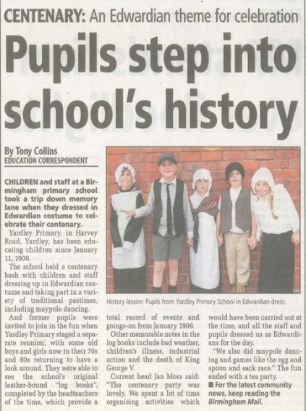
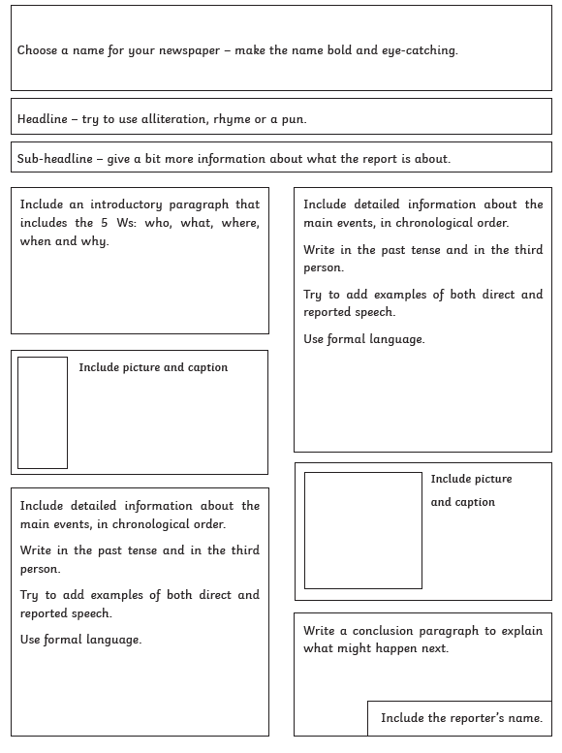
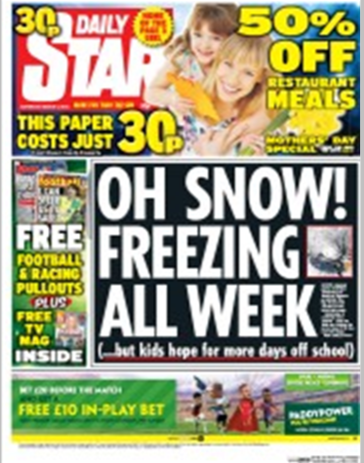

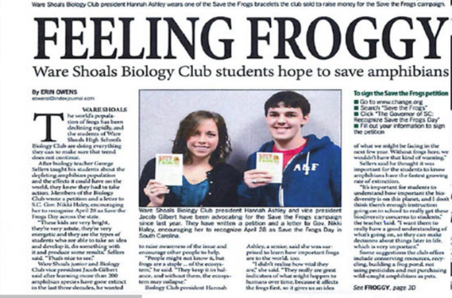
Fat Question:
Are newspapers an old fashioned source of information?
Could society function without getting news from newspapers?

