Spring Term Overview Year 3/4 – History

Spring Term Book(s) – How to Train Your Dragon
Topic – Vikings
Assessment: | VIP quiz at the end of lessons asking children to recap. Then recapping VIPs from the previous lesson at the start of the next one.  Teacher judgement through the final pieces of work. | Very Important Points (VIPs):  - The Vikings were the Norse people who were famously known for sailing from their home in Scandinavia between AD 800 and 1066 to raid and at times trade.  - The Vikings fought using long swords, shields and axes.  - Vikings wore minimal armour. Some would wear chain mail coats, most relied on their wooden shield for protection.  - The armour for some Vikings included; helmet, chain mail, trousers for warmth and leather shoes.  - Some would wear wolf or bear skins. These warriors were often known as ‘berserkers’ because they would go berserk and be fearless in battle.  - Vikings built ‘dragon-ships’ and ‘long ships’ used mainly for raiding and war.  - Vikings were known as 'Danes' by people in Britain.  - Knorrs were another boat they made used for slower passengers and cargo.  - Some Vikings lived in a longhouse. This was made from stone or wood with a thatched or turf roof top. This had one room which they shared with animals too.  - Vikings had many jobs including; farming, craft workers; woodworkers, leatherworkers, jewellers, blacksmiths and potters.  - Vikings had laws but they weren’t written down. If someone broke the law they were called an outlaw, they were forced to live in the wilderness.  - The most powerful Viking was the king. Below the king was the Jarl then Karls and at the bottom were the thralls and slaves.  - Viking longships would be able to sail in shallow water so were able to float on rivers and on the sea. During a raid, a boat would be hauled up to the beach so they could jump pit to fight but also make a quick getaway if needed.  - They bought goods and materials such as silver, silk, spices, wine, jewellery, glass and pottery. In return, they sold items like honey, tin, wheat, wool, wood, iron, fur, leather, fish and walrus ivory.  - The Vikings attacked the monastery in Lindisfarne looking for treasures they could steal and killed many monks who couldn't defend themselves.  - The Danelaw defined the boundary between the Anglo-Saxon kingdoms and the large bits of England that the Vikings had conquered through invasion.  Fat Question:  Would the Vikings be remembered if they only traded?
Links to prior learning (sequencing) and canon book | How to Train Your Dragon:  Children will build upon their prior learning understanding the change from the Romans last half term to the Vikings this half term.
Links to other learning (cross fertilisation) | Science – Forces which links to the flight aspect of the dragon from the reading canon.  Art – Oil pastel linked to the reading canon book.  DT –To create a dragon puppet linked to our canon book.  English – Mythical narrative using the 'How to Train your Dragon' as a basis. A newspaper report linked to the Vikings.  Thematic Questions  The World Beyond Us  Did the Vikings have any awareness of space?  How did they use the stars to help them travel?  Modern Britain  Have the Vikings influenced Modern Britain?  Healthy Bodies & Healthy Minds  How did the Vikings stay healthy?  The World Around Us  How did the Vikings travel?  How do their laws and society differ from Modern Britain? How are they similar?  Culture  Why did the Vikings have multiple Gods?  Technology in Action  How has technology grown since the Vikings?  How much has the technology in boats and ships grown since the Vikings?
Links to future learning | This unit will support the children's learning and understanding of another important historical time which helps to build on their understanding of different times and eras within history. When moving onto UKS2 they will continue to build on the concept of time. In this cycle they look at the Anglo Saxons which will help them to understand the change from Romans to Anglo Saxons and then the Vikings. They can use the knowledge from this half term to help understand the Anglo Saxons.
Character/Wider Development ('50 things', cultural capital, skills) | A trip to the Jorvik centre.

OVERVIEW OF TEACHING SEQUENCE
Key Facts/Learning | Learning Focus or Key Question | Learning Outcomes (NC) | Key Words/  Vocabulary | Greater Depth/SEND | Misconceptions | Activities and Resources
LO: To understand who the Vikings were. | To understand the history behind who the Vikings were and the impact their era has had on Modern Britain. | The Viking and Anglo-Saxon struggle for the Kingdom of England to the time of Edward the Confessor. | Viking, timeline, armour, fight, weapon, longship, warrior, helmet, chain mail, axe, sword, shield, prow, sail, oar, hull, rudder. | Y3  GD- To write a fact file based on ‘How did the Vikings fight?’ Including; their armour, weapons and how they attacked. Pictures are to be drawn with each section.  SEND – Label a warrior and write a couple of simple sentences about their armour.  Y4  GD - Orange task - To write a fact file based on ‘How did the Vikings fight?’ Including; their armour, weapons, how they attacked and the longships. Pictures are to be drawn with each section.  SEND - Label a warrior and write a couple of simple sentences about their armour. | - All Vikings wanted to fight. However some wanted to live a peaceful life.  - Vikings are known for wearing horned helmets but there isn’t any evidence that supports this. | History KS2: The Vikings (animation) - BBC Teach – Very good video about the Vikings coming to Britain. 5 minutes long.  Children will start by learning about the Vikings and who they were. Children will order the timeline as a part of a starter activity. PRINT THE TIMELINE AND CUT UP FOR CHILDREN TO ORDER. Spend some time going through the timeline and the importance of each event.  The main point of this lesson is to understand the timeline of the Vikings and to learn about how they used to fight. This is a common theme throughout the Viking times. Focusing on their armour, weapons, how they attacked and their longships.  Use the document ‘How did Vikings fight?’ to support all tasks.  TASKS Y3  Red task – Draw and label a Viking warrior. Write about the helmet, chain mail, axe, sword and shield.  Blue task - Draw and label a Viking warrior. Write a detailed explanation about all of the armour they wore and the weapons they used.  Orange task - To write a fact file based on ‘How did the Vikings fight?’ Including; their armour, weapons and how they attacked. Pictures are to be drawn with each section.  SEND Purple task – Label a warrior and write a couple of simple sentences about their armour.  TASKS Y4  Red task - Draw and label a Viking warrior. Write a detailed explanation about all of the armour they wore and the weapons they used.  Blue task - To write a fact file based on ‘How did the Vikings fight?’ Including; their armour, weapons and how they attacked. Pictures are to be drawn with each section.  Orange task - To write a fact file based on ‘How did the Vikings fight?’ Including; their armour, weapons, how they attacked and the longships. Pictures are to be drawn with each section.  SEND Purple task - Label a warrior and write a few of simple sentences about their armour.  Deepen the moment  ‘Longships were huge therefore the element of surprise is impossible.’ Do you agree? Explain your answer.  Useful resources  Vikings Facts for Kids (kiddle.co)
LO: To understand what life was like in Viking Britain. | To understand the way of life of the Vikings and how they lived including; family life, jobs, laws, society and the longhouse. | The Viking and Anglo-Saxon struggle for the Kingdom of England to the time of Edward the Confessor. | Viking, longhouse, longship, woodworker, leatherworker, brooches, blacksmith, potter, lathe, thatched, cesspit, dispute, outlaw, duel, jarls, Karls, thralls. | Y3  GD  Orange task - To write an information text on ‘Life in Viking Britain.’  Include information on their housing, family life, jobs and laws. Draw a picture to go with each section.  SEND  Label a longhouse. Write three simple sentences about the features in the longhouse.  Y4  GD  Orange task – To write a diary entry as a Viking describing their housing, family life, jobs, laws and society.  SEND  Label a longhouse. Write four simple sentences about the features in the longhouse. | - Sometimes believed everyone lived in mud huts.  - That society broke down after the Romans left.  - That all Vikings were warriors.  - Vikings were misunderstood because they didn’t keep written records.  - Wealthy Vikings are Jarls.  The Karls weren’t as rich or as important as the Jarls. They did jobs like farming and craft work. | Children will start by recapping the last session. What VIPs can they remember?  Discuss the VIPs for this lesson. Then discuss the fat question.  Go through the slides looking at the different aspects of Viking life in Britain. Use the bitesize page to help with the understanding of these roles.  What was life like in Viking Britain? - BBC Bitesize  Discuss the tasks below.  TASKS Y3  Red task – Draw and label a longhouse. Write a simple explanation about all of the features in a longhouse.  Blue task – Describe family life and housing in Viking Britain. Then draw and label a longhouse.  Orange task - To write an information text on ‘Life in Viking Britain.’  Include information on their housing, family life, jobs and laws. Draw a picture to go with each section.  SEND Purple task – Label a longhouse. Write three simple sentences about the features in the longhouse.  TASKS Y4-  Red task – Describe family life and housing in Viking Britain. Then draw and label a longhouse.  Blue task - To write an information text on ‘Life in Viking Britain.’  Include information on their housing, family life, jobs and laws. Draw a picture to go with each section.  Orange task – To write a diary entry as a Viking describing their housing, family life, jobs, laws and society.  SEND Purple task – Label a longhouse. Write four simple sentences about the features in the longhouse.  Deepen the moment  We think that being a Jarl is the best role in society. Do you agree? Explain your answer.  Other useful resources  https://www.jorvikvikingcentre.co.uk/education/education-projects/shaking-hands-with-the-past/
LO: To understand the Viking raids and invasions. | To understand why the Vikings were known for being violent. This lesson will focus on the Vikings attacking Lindisfarne. | The Viking and Anglo-Saxon struggle for the Kingdom of England to the time of Edward the Confessor. | Lindisfarne, invasion, Viking, landed, monastery, Holy Island, Northumberland, weapon, defenceless, attack, heathen, tribulation. | Y3  GD - Orange task - To write a diary entry as a monk who was at Lindisfarne.  SEND - Complete the sentences and draw a longship.  Y4  Orange task – To write a newspaper report based on the Lindisfarne invasion.  SEND – Complete the sentences and draw a long ship. | - All Vikings wanted to fight. However some wanted to live a peaceful life.  - Vikings are known for wearing horned helmets but there isn’t any evidence that supports this. | Children will start by recapping the last session. What VIPs can they remember?  Children will look at how the Vikings wanted to conquer lands rather than just trading. The children will focus on the Lindisfarne raid. Children can watch the following video based on the Lindisfarne. Children will need to jot notes down to help with their tasks.  The importance of Lindisfarne for the Vikings - KS2 History - BBC Bitesize  TASKS Y3  Red task – Answer the questions about what happened when the Vikings landed in Lindisfarne and draw a longship.  Blue task - Write a short description about what happened when the Vikings landed in Lindisfarne and about longships.  Orange task - To write a short diary entry as a monk who was at Lindisfarne.  SEND Purple task – Complete the sentences and draw a longship.  TASKS Y4  Red task – Write a short description about what happened when the Vikings landed in Lindisfarne and about longships.  Blue task – To write a diary entry as a monk who was at Lindisfarne.  Orange task – To write a newspaper report based on the Vikings landing in Lindisfarne.  SEND Purple task - Complete the sentences and draw a longship.  Deepen the moment  Always, sometimes or never.  Were the Vikings bad? Explain your answer.
Context (big picture learning)
In LKS2, we will be learning about the Vikings and what they were best known for. Children will be looking deeply into how the Vikings acted, fought, raided, lived, traded and explored. They will then use this knowledge to help understand how this had an impact on the future. They will look at who they were and their timeline. Then, they will look at how they lived in Britain including understanding; jobs, family life, housing, society and the laws they had. Next, they will look at how raiding turned into invasions. This topic will help to deepen their learning of how the Vikings came to be and the importance of how their trading and raiding influenced history. The history this half term links to the reading canon book and will help the children to understand the lives of the Vikings to help them understand why the characters are like they are in the book. This learning leads on well from Roman Britain and will help children to continue building on their concept of time throughout history.
Folder name (Trust shared > Primaries > KS2 > Year 3/4 Planning > Cycle B > Spring 1 – How to Train Your Dragon > History)
Lesson one – To understand who the Vikings were.
Lesson two – To understand what life was like in Viking Britain.
Lesson three – To understand the Viking raids and invasions.

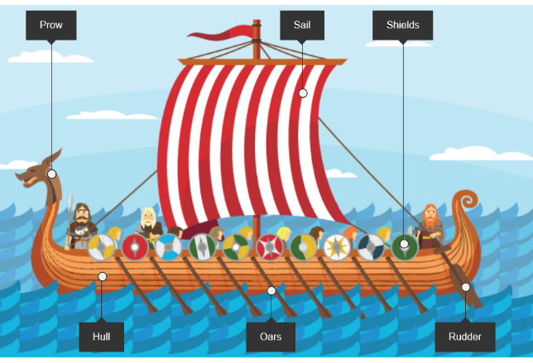
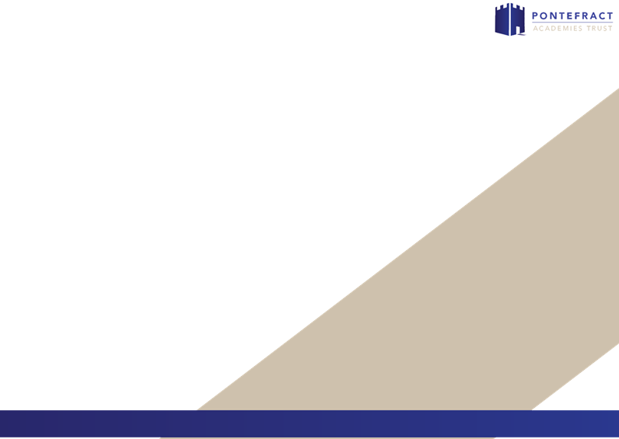
VIPs:
- The Vikings were the Norse people who were famously known for sailing from their home in Scandinavia between AD 800 and 1066 to raid and at times trade.
- The Vikings fought using long swords, shields and axes.
- Vikings wore minimal armour. Some would wear chain mail coats, most relied on their wooden shield for protection.
- The armour for some Vikings included; helmet, chain mail, trousers for warmth and leather shoes.
- Some would wear wolf or bear skins. These warriors were often known as ‘berserkers’ because they would go berserk and be fearless in battle.
- Vikings built ‘dragon-ships’ and ‘long ships’ used mainly for raiding and war.
- Vikings were known as 'Danes' by people in Britain.
- Knorrs were another boat they made used for slower passengers and cargo.
- Some Vikings lived in a longhouse. This was made from stone or wood with a thatched or turf roof top. This had one room which they shared with animals too.
- Vikings had many jobs including; farming, craft workers; woodworkers, leatherworkers, jewellers, blacksmiths and potters.
- Vikings had laws but they weren’t written down. If someone broke the law they were called an outlaw, they were forced to live in the wilderness.
- The most powerful Viking was the king. Below the king was the Jarl then Karls and at the bottom were the thralls and slaves.
- Viking longships would be able to sail in shallow water so were able to float on rivers and on the sea. During a raid, a boat would be hauled up to the beach so they could jump pit to fight but also make a quick getaway if needed.
- They bought goods and materials such as silver, silk, spices, wine, jewellery, glass and pottery. In return, they sold items like honey, tin, wheat, wool, wood, iron, fur, leather, fish and walrus ivory.
- The Vikings attacked the monastery in Lindisfarne looking for treasures they could steal and killed many monks who couldn't defend themselves.
- The Danelaw defined the boundary between the Anglo-Saxon kingdoms and the large bits of England that the Vikings had conquered through invasion.
Key Vocabulary
Viking – The Vikings were the Norse people who were famously known for sailing from their home in Scandinavia between AD 800 and 1066 to raid and at times trade.
Pagan - Paganism is a term that covers a great number of spiritual and religious beliefs, someone who follows these beliefs is known as a Pagan.
Danelaw - The Danelaw defined the boundary between the Anglo-Saxon kingdoms and the large bits of England that the Vikings had conquered through invasion.
settlement – Places where people live.
runes – The Viking alphabet.
invasion – To enter as an enemy, by force, in order to conquer a place.
conflict / fight – A struggle or clash between opposing forces; battle.
conquer – Taking compete control of another land.
Scandinavia – A group of countries in northern Europe.
brutal / savage – A violent and cruel person.
expedition – A journey made for a specific purpose.
navigation – Directing a ship from one place to another.
combat – A fight or contest between individuals or groups.
pillage – To rob using violence.
plunder – Steal goods from a place or person, typically using force in time of war or civil disorder.
heathen – No religion.
raid – A rapid surprise attack on an enemy.
conquest – Act or process of conquering.
voyage – A course of travel or passage, especially a long journey by water to a distant place.
knorr – A slow passenger and cargo ship.
armour – A defensive covering.
weapon – Something used to injure, defeat, or destroy.
longship – Longship were seagoing vessels made and used for trade, exploring and raiding.
Craftworkers- woodworkers, leatherworkers, jewellers, blacksmiths and potters.
outlaw - If someone broke the law they were called an outlaw, they were forced to live in the wilderness.
duel – A combat between two people.
cesspit – A pit for disposal of refuse such as sewage.
dispute – To engage in argument.
tribulation – A cause of great trouble or suffering.
Monastery – A building/s occupied by a community of monks living under religious vows.
defenceless – Without defence, vulnerable.
Lindisfarne (Holy Island) – An island off the northeast coast of England.
Intent:
For this topic based on the Vikings, we will learn about who they were by looking in detail at their timeline. We will then focus on the fighting aspect of the Vikings including learning about warriors. Next, we will learn about Viking Britain including learning about; family life, housing, jobs, laws and society. Finally, we will learn about Vikings raids and invasions and in particular the Lindisfarne raid.

Year 3/4 History Knowledge Organiser: The Vikings
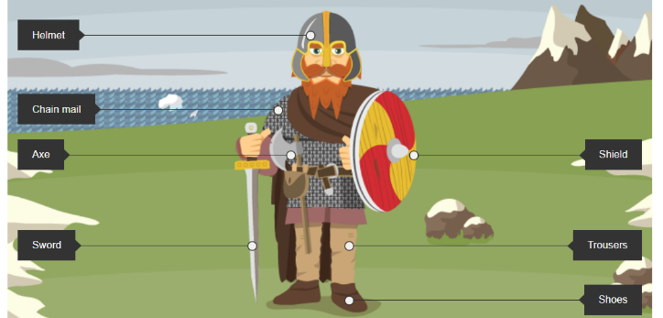
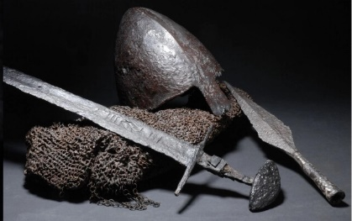
Fat Question: Would the Vikings be remembered if they only traded?

Viking timeline
AD 787 – The Vikings arrived in Britain.
AD 793 – The Vikings attack from Norway. They attack the Monastery of Lindisfarne in Northumbria. The following year they attacked northern Britain, now known as Scotland.
AD 866 – The Vikings captured the city of York.
AD 871 – Alfred the Great becomes King of Wessex. He drives the invading Vikings from the south but they stay in the north and the east.
AD 878 – By this time, the Vikings had settled permanently in England, overran Wessex and forced King Alfred into hiding.
AD 886 – King Alfred agrees to a treaty with the Vikings. Alfred keeps the west and the Vikings are given the east which is later known as ‘Danelaw.’
AD 900 – The Vikings establish rule over Scotland.
AD 954 – The last Viking King of Jorvik (York,), Eric Bloodaxe, is forced out of York.
AD 1013 – King Sven of Denmark and his son Cnut sail up the rivers Humber and Trent to claim the throne in Danelaw and Ethelred, the Saxon King, flees abroad.
AD 1014 – King Sven dies and Ethelred returns to rule England again.
AD 1016 – King Ethelred dies. His son, Edmund Ironside, becomes king for a few months until he also dies. Cnut becomes King of the Danes and King of England.
AD 1035 - King Cnut dies. His sons Harold Harefoot and Hardicanute share the ruling of England. Harold dies in 1040 and Hardicanute becomes the sole ruler of England.
AD 1042 - Ethelred’s second son, Edward III is invited to return from Normandy to become the King of England. Edward III was better known as ‘Edward the Confessor’ due to his extreme piety.
AD 1066 - The last Anglo-Saxon king, King Harold, is defeated by William the Conqueror at the Battle of Hastings and Norman Britain begins.

