**Spring Overview Year 3 – Maths**

|  |  |  |
| --- | --- | --- |
| **Spring Term Book – How To Train Your Dragon** | | |
| **Topic(s) –**  **Multiplication and Division**  **Money**  **Statistic** | | **Guide Time = 7 weeks** |
| **Assessment:** | Termly assessments  White Rose end of unit assessments  Teacher judgements | **Very Important Points (VIPs):**  **Multiplication and Division**   * Multilpying will produce a greater number. * Dividing will produce a number which is less than the given number. * Multiplication and division have an inverse relationship. * Multiplication is commutative. * Doubling connects the 2, 4 and 8 times table. * Odd numbers 1 ,3, 5, 7 , 9 * Even numbers 0, 2, 4, 6, 8 * Multiplication facts can be used to work out division facts. * Understand multiplication as scaling. * Know the relationship between multiplication and repeated addition. * Know the relationship between division and repeated subtraction. * See connections bewteen fractions and division.   **Fat Questions:**  What relationships can you find between a number of calcuations?  **Money**   * Different currency is used all over the world but in England we use pounds and pence. * There is 100 pence in a pound * There are 8 different coins that are used in the British currecny and are four different notes used. * The largest note is a fifty pound note but it is very rare. * It is advised to add the pounds first when adding money. You can then exchange the pennies in to pounds if necessary * Number lines can be used to add and subtract money   **Fat Questions:**  Why do different countries have different currencies?  We have the Queen on British money. What / Who do you think other countries have on their money?  **Statistics**   * Each symbol in a pictogram has a value. * Half a symbol represents half of the value. * A bar chart has a vertical scale (axis) which is used to represent or read the total for different categories (bars) * The higher the data represented on a bar chart, the higher the increments may be on the scale. * A table has rows (horizontal) and columns (vertical) which are labelled to help us interpret and categorise certain information.   **Fat Questions:**  When might you need to gather data in real life?  Which would be the most appropriate chart or graph and why? |
| **Links to prior learning (sequencing) and canon book** | **Year 2 National Curriculum – Multiplication and Division**  Pupils should be taught to:   * recall and use multiplication and division facts for the 2, 5 and 10 multiplication tables, including recognising odd and even numbers * calculate mathematical statements for multiplication and division within the multiplication tables and write them using the multiplication (×), division (÷) and equals (=) signs * show that multiplication of 2 numbers can be done in any order (commutative) and division of 1 number by another cannot * solve problems involving multiplication and division, using materials, arrays, repeated addition, mental methods, and multiplication and division facts, including problems in contexts   **Year 2 National Curriculum – Money**  Pupils should be taught to:   * recognise and use symbols for pounds (£) and pence (p); combine amounts to make a particular value * find different combinations of coins that equal the same amounts of money * solve simple problems in a practical context involving addition and subtraction of money of the same unit, including giving change   **Year 2 National Curriculum – Statistics**  Pupils should be taught to:   * interpret and construct simple pictograms, tally charts, block diagrams and simple tables * ask and answer simple questions by counting the number of objects in each category and sorting the categories by quantity a * ask and answer questions about totalling and comparing categorical data |
| **Links to other learning (cross fertilisation)** | PE -. Counting scored points e.g. If a goal (or other means of scoring points) is worth 3 points, how many points will you award the team who have scored 11 goals?   * Constructing simple tables or charts to record scores, race times or team points.   ICT – Use of online games to support the rapid recall of number facts.  Thematic questions:  The world beyond us  How do astronauts use multilpcation and division?  Modern Britain  Have written methods changed over time?  Healthy body, Healthy minds  How can we apply our multiplication knowledge in sports?  How can we apply our multiplication and division knowledge when scoring a try in a game of rugby?  The world around us  How will division assist us when being fair to others?  Culture  Can multiplication and division help us when planning a celebration?  Technology in action  Has the internet changed how we learn number facts? |
| **Links to future learning** | The skills taught this half term will be applied and built upon throughout the year. In year 4, children will be introduced to to the remaining times tables and multiplication facts as the year progresses. They will be able to apply their knowledge of multiplication and division to the numbers associated with the year 4 scheme of learning. Also in year 4, pupils will build on their knowledge of data tables and charts to make comparisons and solve problems, before learning how to use time graphs. |
| **Character/Wider Development ('50 things', cultural capital, skills)** | 50 Things are personal to each school. However, these skills help with life skills including spending ‘pocket money’ knowing and understanding how much you have to start with and what you have left.  These skills also help with baking, working with bigger numbers and understanding their worth in real life situations.  The ability to read simple graphs & charts helps children to read such sources of information in real life situations & to use them to gather their own data. For example, recording & counting school council votes. |

|  |  |  |  |  |  |  |
| --- | --- | --- | --- | --- | --- | --- |
| **Key**  **Facts/**  **Learning** | **Learning Focus or Key Question** | **Learning Outcomes (NC)** | **Key Words/**  **Vocabulary** | **Greater Depth/SEND** | **Misconceptions** | **Activities and Resources** |
| **Multiplication and Division** | Comparing statements | Pupils should be taught to:   * recall and use multiplication and division facts for the 3, 4 and 8 multiplication tables * write and calculate mathematical statements for multiplication and division using the multiplication tables that they know, including for two-digit numbers times one-digit numbers, using mental and progressing to formal written methods * solve problems, including missing number problems, involving multiplication and division, including positive integer scaling problems and correspondence problems in which n objects are connected to m objects | Repeated addition  Multiply  Times  Equal to  Greater than  Less than | GD pupils should be exposed to more complex problems with multiple multiplication before the comparison statement.  SEND will use pictorial representations such as base 10 to help understanding. | Children may get confused with the number of different symbols used. The may also be unsure which part of the number sentence they should work out. | Classroom Secrets [Step 1](https://classroomsecrets.co.uk/category/maths/year-3/spring-block-1-multiplication-and-division-year-3/step-1-spring-block-1-multiplication-and-division-year-3)  Third Space Learning lesson 1  (Trust shared > Primaries > KS2 > Year 3/4 Planning > Maths – YEAR 3)  White Rose Maths Hub  <https://wrm-13b48.kxcdn.com/wp-content/uploads/2019/01/Year-3-2018-19-Spring-Term-Block-1-FINAL.pdf> |
| Related calculations | Multiply  Times related  Repeated addition  Ten times table  Lots of  Multiplied by | GD children will use reasoning questions to prove why related calculations are correct.  SEND children can use base ten as a concrete example. | Fact Families are effective when showing the inverse calculations however teachers must check pupils’ understanding as they may make mistakes with the division e.g.  6 X 4 = 24  4 X 6 = 24  6 ÷ 4 = 24  4 ÷ 6 = 24  When multiplying by 10 children must make sure they don’t forget to add the 0 on at the end. | Classroom Secrets Step 2  <https://classroomsecrets.co.uk/category/maths/year-3/spring-block-1-multiplication-and-division-year-3/step-2-spring-block-1-multiplication-and-division-year-3>  Third Space Learning lesson 2  (Trust shared > Primaries > KS2 > Year 3/4 Planning > Maths – YEAR 3)  White Rose Maths Hub  <https://wrm-13b48.kxcdn.com/wp-content/uploads/2019/01/Year-3-2018-19-Spring-Term-Block-1-FINAL.pdf> |
| Multiplying 2 digits by 1 digit (1) | Multiply  Times  Carrying  Colum method  Tens  Ones  Partitioning | GD pupils provided with column method multiplications problems with mistakes. Pupils use their understanding to spot and explain the mistakes.  SEND pupils will use a variety of pictorial representations to show multiplication. Including place value grids and base 10. | Pupils may be using column method for some calculations when appropriate. Teachers need to ensure that this is done correctly. Use the resource wall/display for modelling good examples. | Classroom Secrets Step 3  <https://classroomsecrets.co.uk/category/maths/year-3/spring-block-1-multiplication-and-division-year-3/step-3-spring-block-1-multiplication-and-division-year-3>  Third Space Learning lesson 3  (Trust shared > Primaries > KS2 > Year 3/4 Planning > Maths – YEAR 3)  White Rose Maths Hub  <https://wrm-13b48.kxcdn.com/wp-content/uploads/2019/01/Year-3-2018-19-Spring-Term-Block-1-FINAL.pdf> |
| Multiplying 2 digits by 1 digit (2) | Multiply  Times  Carrying  Colum method  Tens  Ones | GD children can apply what they have learnt to solve more complex open- ended problems.  SEND children can use their knowledge of repeated addition and use pictorial representations so help solve problems. | Pupil may perform the exchange incorrectly. They may forget to carry the tens and put it under the answer column to be added later. See example: | Classroom Secrets Step 4  <https://classroomsecrets.co.uk/category/maths/year-3/spring-block-1-multiplication-and-division-year-3/step-4-spring-block-1-multiplication-and-division-year-3>  Third Space Learning lesson 4  (Trust shared > Primaries > KS2 > Year 3/4 Planning > Maths – YEAR 3)  White Rose Maths Hub  <https://wrm-13b48.kxcdn.com/wp-content/uploads/2019/01/Year-3-2018-19-Spring-Term-Block-1-FINAL.pdf> |
| Dividing 2 digits by 1 digit (1) | Sharing  Divide  Equal groups  Tens  Ones  Partitioning | GD pupils can use what they have learnt to answer true or false to statements with an explanation.  SEND use base ten and column grid for visual representation of sharing. | When using place value counters to divide children may place the counters in to the wrong columns. | Classroom Secrets Step 5  <https://classroomsecrets.co.uk/category/maths/year-3/spring-block-1-multiplication-and-division-year-3/step-5-spring-block-1-multiplication-and-division-year-3>  Third Space Learning lesson 5  (Trust shared > Primaries > KS2 > Year 3/4 Planning > Maths – YEAR 3)  White Rose Maths Hub  <https://wrm-13b48.kxcdn.com/wp-content/uploads/2019/01/Year-3-2018-19-Spring-Term-Block-1-FINAL.pdf> |
| Dividing 2 digits by 1 digit (2) | Sharing  Divide  Equal groups  Tens  Ones  Partitioning | GD children can use their knowledge to compare division statements.  SEND will continue to use base ten or place value counters to share equally and use these concrete examples to physically see the exchange taking place. | Children may get confused by having to share the tens first as when working with multiplication they had to start in the ones column.  This must be reiterated in the VIPs and reminders through the lesson to avoid mistakes. | Classroom Secrets Step 6  <https://classroomsecrets.co.uk/category/maths/year-3/spring-block-1-multiplication-and-division-year-3/step-6-spring-block-1-multiplication-and-division-year-3>  Third Space Learning lesson 6  (Trust shared > Primaries > KS2 > Year 3/4 Planning > Maths – YEAR 3)  White Rose Maths Hub  https://wrm-13b48.kxcdn.com/wp-content/uploads/2019/01/Year-3-2018-19-Spring-Term-Block-1-FINAL.pdf |
| Dividing 2 digits by 1 digit (3) | Sharing  Divide  Equal groups  Tens  Ones  Partitioning | GD children will use a variety of pictorial representations, number line and progress to bus stop method of division.  SEND children will continue to use their knowledge of sharing in to equal groups by using concrete examples. The children will then see the remainder as the extra part left over from the equal groups. Through explicit explanation they will understand this is known as the remainder. | Children may think that because the numbers cannot divide equally that the problem cannot be solved.  An explicit explanation of what remainders are and how to record them is crucial. | Classroom Secrets Step 7  <https://classroomsecrets.co.uk/category/maths/year-3/spring-block-1-multiplication-and-division-year-3/step-7-spring-block-1-multiplication-and-division-year-3>  Third Space Learning lesson 7  (Trust shared > Primaries > KS2 > Year 3/4 Planning > Maths – YEAR 3)  White Rose Maths Hub  <https://wrm-13b48.kxcdn.com/wp-content/uploads/2019/01/Year-3-2018-19-Spring-Term-Block-1-FINAL.pdf> |
| Scaling | Scaling  Times as many  In total altogether  Sharing  Divide  Equal groups  Tens  Ones  Partitioning | **Think about multiplication as scaling**  You can also help your child by introducing the idea of multiplication as scaling in the real world. Scaling is used when we use multiplication to change the size of the original quantity. For example:  ‘If you have saved £12 and I have saved four times as much as you, how much money have I saved?’  SEND Classroom Secrets has a multiplication and division learning video that may be useful alongside visual representations. | Children may add one extra when scaling as they might include the original number too. For example  There are 3 times as many girls than boys. T  A variety of examples and non examples should be used to show pupils true understanding. | Classroom Secrets Step 8  <https://classroomsecrets.co.uk/category/maths/year-3/spring-block-1-multiplication-and-division-year-3/step-8-spring-block-1-multiplication-and-division-year-3>  Third Space Learning lesson 8  (Trust shared > Primaries > KS2 > Year 3/4 Planning > Maths – YEAR 3)  White Rose Maths Hub  <https://wrm-13b48.kxcdn.com/wp-content/uploads/2019/01/Year-3-2018-19-Spring-Term-Block-1-FINAL.pdf> |
| How many ways? | Sharing  Divide  Equal groups  Tens  Ones  Partitioning | GD children will apply what they have learnt to solve more complex number problems with less pictorial representations.  For SEND children it is essential to have practical equipment to sort in to different groups. The children must see the visual representation of each possibility. |  | Classroom Secrets Step 9  <https://classroomsecrets.co.uk/category/maths/year-3/spring-block-1-multiplication-and-division-year-3/step-9-spring-block-1-multiplication-and-division-year-3>  Third Space Learning lesson 9  (Trust shared > Primaries > KS2 > Year 3/4 Planning > Maths – YEAR 3)  White Rose Maths Hub  <https://wrm-13b48.kxcdn.com/wp-content/uploads/2019/01/Year-3-2018-19-Spring-Term-Block-1-FINAL.pdf> |
| **Money** | Pounds and pence | Pupils should be taught to:   * identify the value of different coins and notes. * add and subtract amounts of money to give change, using both £ and p in practical contexts * convert pounds and pence. | Money  Pounds - £  Pence – P  Difference  Total  Notes  Coins  Amounts  Pay  Change  Price  Budget  Spend  Convert  Conversion  Bar model  Equal amount  Greater less  More than  Symbol  Greater value  Greatest amount  Compare | GD children can solve more complex word problems using a variety of coins.  Send children should have coin word mat as well as physical coins to count. | Children may need reminding that not all silver coins or bronze have the same value.  Children should be provided with a visual representation of the coins and their value. | Classroom Secrets Step 1  [**https://classroomsecrets.co.uk/category/maths/year-3/spring-block-2-money/step-1-spring-block-2-money**](https://classroomsecrets.co.uk/category/maths/year-3/spring-block-2-money/step-1-spring-block-2-money)  Third Space Learning lesson 1  (Trust shared > Primaries > KS2 > Year 3/4 Planning > Maths – YEAR 3)  White Rose Maths Hub  <https://wrm-13b48.kxcdn.com/wp-content/uploads/2019/01/Year-3-2018-19-Spring-Term-Block-2-FINAL.pdf> |
| Converting pounds and pence | GD children can systematically look at different combinations of coins to create the same value.  SEND children should use their knowledge of number bonds to 100. Number bonds mats to help recall facts and visual representation of coins. | Children could confuse £1 and £2 coins. As well as 1p and 2p coins. Clear images should be used to help prevent this, | Classroom Secrets Step 2  <https://classroomsecrets.co.uk/category/maths/year-3/spring-block-2-money/step-2-spring-block-2-money>  Third Space Learning lesson 2  (Trust shared > Primaries > KS2 > Year 3/4 Planning > Maths – YEAR 3)  White Rose Maths Hub  <https://wrm-13b48.kxcdn.com/wp-content/uploads/2019/01/Year-3-2018-19-Spring-Term-Block-2-FINAL.pdf> |
| Adding money | GD children will use a variety of representation for addition such as part whole models and bar models.  SEND children should use play money to role play. Use a couple of coins and increase variations of coins depending on ability. | When adding notes and coins children may add all the coins together as pence and then only express pounds as notes.  For example:  £5 and 230p | Classroom Secrets Step 3  <https://classroomsecrets.co.uk/category/maths/year-3/spring-block-2-money/step-3-spring-block-2-money>  Third Space Learning lesson 3  (Trust shared > Primaries > KS2 > Year 3/4 Planning > Maths – YEAR 3)  White Rose Maths Hub  <https://wrm-13b48.kxcdn.com/wp-content/uploads/2019/01/Year-3-2018-19-Spring-Term-Block-2-FINAL.pdf> |
| Subtracting money | GD children will have access to a variety of methods and focus on problems that involve exchanging the money from pounds to pence.  SEND children will use model money to physically remove the coins to work out the subtraction. | If using column method for subtraction children must remember to exchange first.  They must also be aware of which column to put the numbers in correctly. | Classroom Secrets Step 4  <https://classroomsecrets.co.uk/category/maths/year-3/spring-block-2-money/step-4-spring-block-2-money>  Third Space Learning lesson 4  (Trust shared > Primaries > KS2 > Year 3/4 Planning > Maths – YEAR 3)  White Rose Maths Hub  <https://wrm-13b48.kxcdn.com/wp-content/uploads/2019/01/Year-3-2018-19-Spring-Term-Block-2-FINAL.pdf> |
|  | Giving change | GD use role play with a wide variety of notes and coins. Encourage children to work out change using mental methods.  SEND children also use roleplay but with a reduced number of coins. Can use number lines too. | Children may confuse change with the amount spent.  Children may confuse size of coin with value of coin. They may think bigger coin = bigger value. | Classroom Secrets Step 5  <https://classroomsecrets.co.uk/category/maths/year-3/spring-block-2-money/step-5-spring-block-2-money>  Third Space Learning lesson 5  (Trust shared > Primaries > KS2 > Year 3/4 Planning > Maths – YEAR 3)  White Rose Maths Hub  <https://wrm-13b48.kxcdn.com/wp-content/uploads/2019/01/Year-3-2018-19-Spring-Term-Block-2-FINAL.pdf> |
| **Key**  **Facts/**  **Learning** | **Learning Focus or Key Question** | **Learning Outcomes (NC)** | **Key Words/**  **Vocabulary** | **Greater Depth/SEND** | **Misconceptions** | **Activities and Resources** |
| **Statistics** | Interpret Pictograms (VF) | Interpret and present data using bar charts, pictograms and tables.  Solve one-step and two-step questions [for example, ‘How many more?’ and ‘How many fewer?’] using information presented in scaled bar charts and pictograms and tables. | * Interpret * Symbol * Pictogram * Bar chart * Table * Most * Least * More than * Less than * Fewer than * Interpret * Represent * Scale * Data | SEND children will interpret pictograms where symbols represent 2, 5 or 10. GD children will interpret symbols which represent groups of 3, 4 or 8, as well as interpreting quarters of a symbol. | Children may confuse one symbol as representing one object. | Classroom Secrets Step 1  <https://classroomsecrets.co.uk/category/maths/year-3/spring-block-3-statistics/step-1-spring-block-3-statistics/>  White Rose Maths Hub  <https://wrm-13b48.kxcdn.com/wp-content/uploads/2020/12/Year-3-Spring-block-3-Statistics.pdf> |
|  | Interpret Pictograms (RPS) |
|  | Bar Charts (VF) | SEND children will work with scales of 2 or 10. GD children will work with scales of 3, 4 or 8. | Children will not have drawn bar charts before, so will need to be taught to start form zero. They may also get confused & join the columns of each bar to the scale or make each bar different widths. Clear modelling will be required. | Classroom Secrets Step 2  <https://classroomsecrets.co.uk/category/maths/year-3/spring-block-3-statistics/step-2-spring-block-3-statistics/>  White Rose Maths Hub  <https://wrm-13b48.kxcdn.com/wp-content/uploads/2020/12/Year-3-Spring-block-3-Statistics.pdf> |
| Bar Charts (RPS) |
|  | Tables (VF) | SEND children will use data to solve one-step problems. GD children will solve multi-step problems with different operations. | Children may not be familiar with a range of tables, so will need modelling how to read and interpret them. | Classroom Secrets Step 3  <https://classroomsecrets.co.uk/category/maths/year-3/spring-block-3-statistics/step-3-spring-block-3-statistics/>  White Rose Maths Hub  <https://wrm-13b48.kxcdn.com/wp-content/uploads/2020/12/Year-3-Spring-block-3-Statistics.pdf> |
| Tables (RPS) |
| Context (big picture learning)  Mathematics is an important, creative discipline that helps us to understand and change the world. We want all of our children within the Pontefract Academies Trust to experience all that mathematics has to offer and to develop a sense of curiosity about the subject with a clear understanding. When they leave us, we want them to continue their love of maths and use it continuously and positively in their future lives.  We foster a positive ‘growth mind-set’ attitude and we promote the fact that we believe that all children can achieve in mathematics. We teach for secure and deep understanding of mathematical concepts through manageable, bespoke steps and cross fertilize at every opportunity. VIPs (Very Important Points) are implemented in every lesson to ensure knowledge and skills are revisited and retained over time. We use mistakes and misconceptions as an essential part of learning and provide challenge through rich and sophisticated reasoning and problem-solving activities. At our school, the majority of children will be taught the content from their year group only. They will spend time becoming true masters of content, applying and being creative with new knowledge in multiple ways  Children will further their understanding of multiplication and division. This will show a clear progression from KS1 and ensure children are prepared with the skills and knowledge when completing formative assessments. By building on the Mathematical foundations they have already secured, it will result in the development of skills, which can be applied into the world around them. Once children have secured the knowledge and skills required in year 3 it will ensure they are ready to progress into year 4 confidently and deepen their learning. | | | | | | |

**Intent**

During this block of learning you will review the value of different coins and notes.

You will add and subtract amounts of money to give change, using both £ and p in practical contexts.

You also learn how to convert pounds and pence.

**Year 3 Knowledge Organiser: Measure Money**

**Converting pounds and pence**

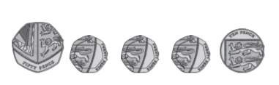

120 pence

100 pence is £1

Therefor 120 pence is £1 and 20 pence

120p = £1.20

**Fat Questions:**

Why do different countries have different currencies?

We have the Queen on British money. What / Who do you think other countries have on their money?

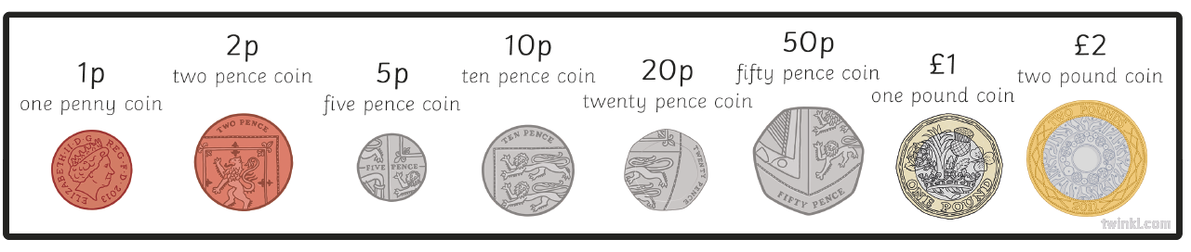

**Pounds and pence**

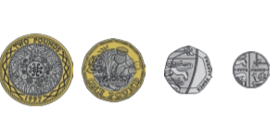

£3 and 25 pence

**Using a number line for subtracting money**

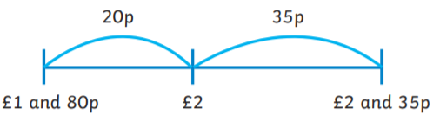

£2 and 35p - £1 and 80p

= 55p

**VIPs**

* Different currency is used all over the world but in England we use pounds and pence.
* There is 100 pence in a pound
* There are 8 different coins that are used in the British currecny and are four different notes used.
* The largest note is a fifty pound note but it is very rare.
* It is advised to add the pounds first when adding money. You can then exchange the pennies in to pounds if necessary
* Number lines can be used to add and subtract money

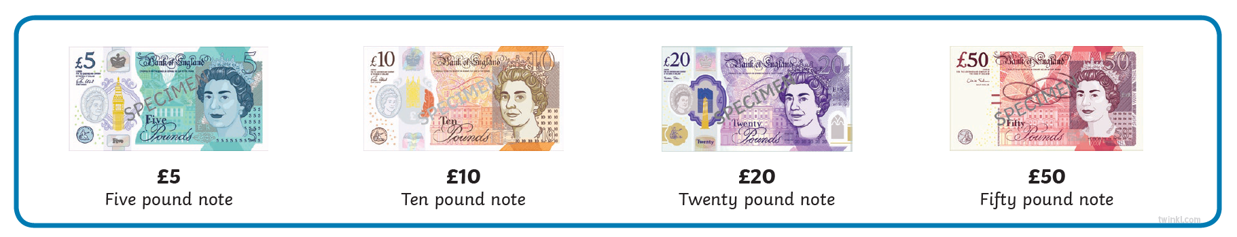

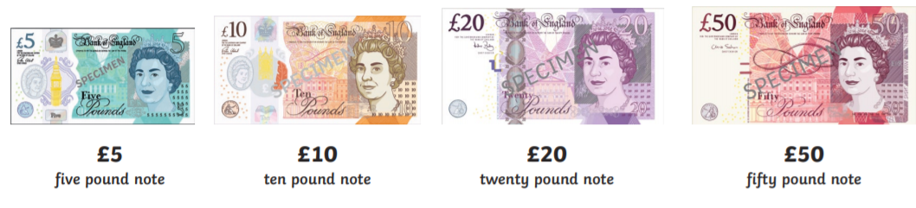

**Key vocabulary**

Money

Pounds - £

Pence – P

Difference

Total

Notes

Coins

Amounts

Pay

Change

Price

Budget

Currency

Spend

Convert

Conversion

Bar model

Equal amount

Greater less

More than

Symbol

Greater value

Greatest amount

Compare



**Converting pounds and pence**



120 pence

100 pence is £1

Therefor 120 pence is £1 and 20 pence

120p = £1.20

Spend

Convert

Conversion

Bar model

Equal amount

Greater less

More than

Symbol

Greater value

Greatest amount

Compare

Cost

Spend

Spend



**Multiplication methods – with regrouping**

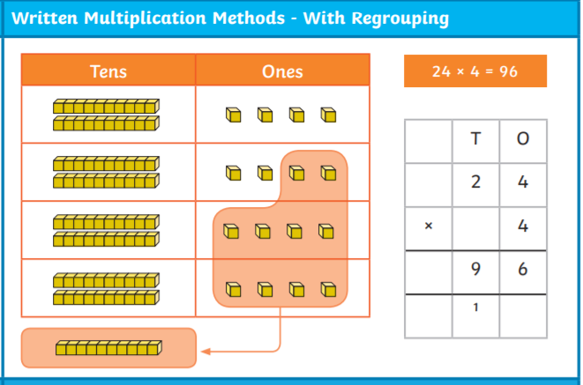

**Key vocabulary**

Equal, same as, groups, add, repeated addition, multiply, times, array, product, groups of, lots of, multiplied by, share equally, equal groups, divide by, sharing, equal, equivalent, inverse, calculation, calculating, place value, whole number, fact family, pictorial representation, partitioning, concrete representation

**Multiplication methods – without regrouping**

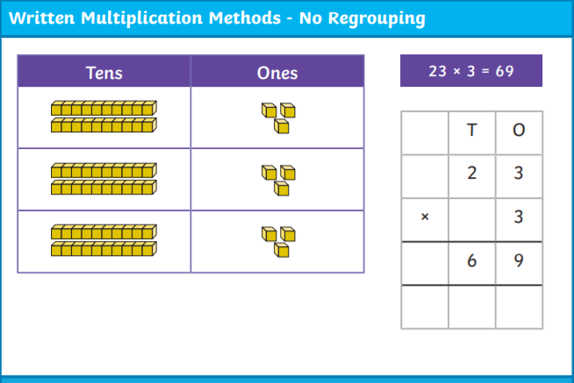

**Year 3 Knowledge Organiser: Multiplication and Division**

**VIPs**

Dividing will produce a number which is less than the given number.

Multiplication and division have an inverse relationship.

Multiplication is commutative.

Doubling connects the 2, 4 and 8 times table.

Odd numbers: 1 ,3, 5, 7 , 9

Even numbers: 0, 2, 4, 6, 8

Multiplication facts can be used to work out division facts.

Understand multiplication as scaling.

Know the relationship between multiplication and repeated addition.

Know the relationship between division and repeated subtraction.

See connections bewteen fractions and division.

Equivalent means equal in value.



**Division methods – with regrouping**

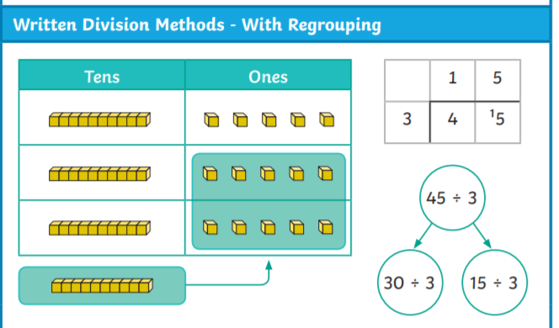

**Fat Questions**

What relationships can you find between a number of calcuations?

Are pictorial representations always the most appropriate when dividing?

When might you use multipliation or division in real life?

**Related calculations**

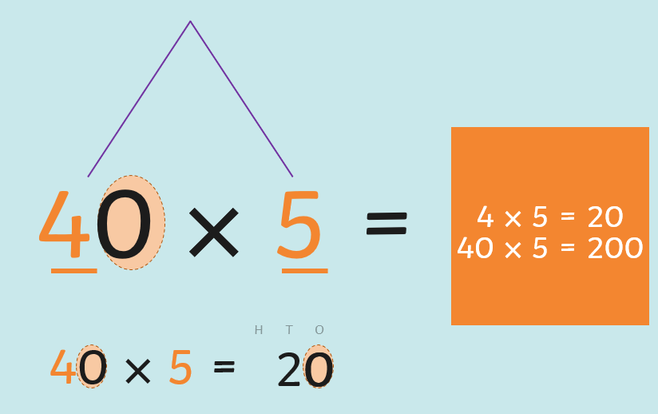

**Intent**

Children will be able to write and calculate mathematical statements for multiplication and division using the multiplication tables that they know, including for two-digit numbers times one-digit numbers, using mental and progressing to formal written methods

Children will solve problems, including missing number problems, involving multiplication and division, including positive integer scaling problems and correspondence problems.

**Array**

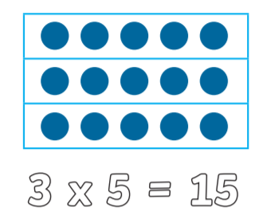

**Division methods – without regrouping**

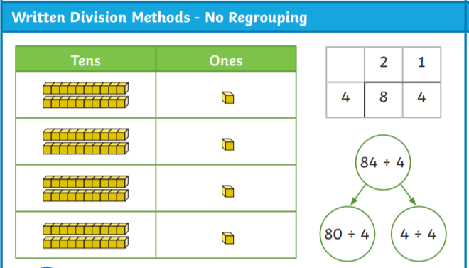



**Key vocabulary**

* Interpret
* Symbol
* Pictogram
* Bar chart
* Table
* Most
* Least
* More than
* Less than
* Fewer than
* Interpret
* Represent
* Scale
* Data

**VIPs**

Each symbol in a pictogram has a value.

Half a symbol represents half of the value.

A bar chart has a vertical scale (axis) which is used to represent or read the total for different categories (bars)

The higher the data represented on a bar chart, the higher the increments may be on the scale.

A table has rows (horizontal) and columns (vertical) which are labelled to help us interpret and categorise certain information.

**Tables**

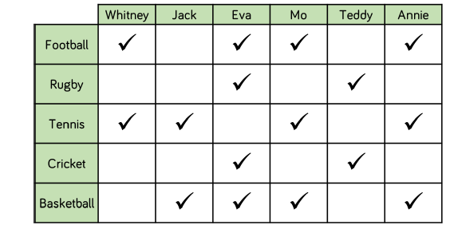

**Pictograms**

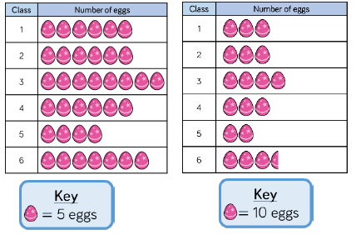

**Year 3 Knowledge Organiser: Statistics**



**Prior Learning – Tally Charts**

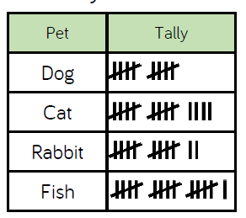

**Fat Questions**

When might you need to gather data in real life?

Which would be the most appropriate chart or graph and why?

**Intent**

Children will be able to interpret and present data using bar charts, pictograms and tables.

Children will be able to solve one-step and two-step questions [for example, ‘How many more?’ and ‘How many fewer?’] using information presented in scaled bar charts and pictograms and tables.

**Bar Charts**

