Spring Term Book – How To Train Your Dragon
Topic(s) - Fractions |  | Guide Time = 6 weeks
Assessment: | White Rose end of unit assessments  End of term assessments  Weekly arithmetic tests  Teacher judgements | Very Important Points (VIPs):  A fraction is a representation of a whole.  A Proper Fraction has a numerator that is smaller.  To find a fraction of a number, divide by the denominator and multiply by numerator  A fraction is a numerical representation for part of a whole.  The numerator tells how many pieces of the whole the fraction represents.  The denominator tells how many equal pieces the whole is divided into.  Fractions with numerator 1 are called unit fractions.  Fractions in which the numerator is more than or equal to the denominator are called improper fractions.  Mixed fractions consist of a whole number along with a proper fraction.  Fractions in which the numerator is more than or equal to the denominator are called  improper fractions.  To add fractions with the same denominator add the top numbers and put the answer over the same denominator. Then simplify the fraction if needed.  Children need to understand how many equal parts are equivalent to a whole e.g. 9/9 = 1, 18/9 = 2 etc.  When finding a fraction of an amount, the key rule to remember is to divide the amount by the denominator and multiply your answer by the numerator.  Fat Questions:  Why do we need fractions, what is the purpose behind them in our everyday life?
Links to prior learning (sequencing) and canon book | How To Train Your Dragon  Children will have knowledge of place value from the autumn term.  They will also have carried out addition and subtraction calulations which will help them with quick calculations when adding/subtracting fractions.  Children should build on the knowledge obtained from KS1 which includes;  recognise, find, name and write fractions 1/3, ¼, ½ and ¾ of a length, shape, set of objects or quantity.  Write simple fractions for example, ½ of 6 = 3 and recognise the equivalence of 2/4 and ¼.  In year 3, children will have counted in tenths, recognise fractions as a discrete set of objects unit fractions and non-unit fractions with a small denominator. They will have also completed addition and subtraction of fractions with the same denominator.
Links to other learning (cross fertilisation) | Active Maths- Children to complete extra maths questions this could be fluency, reasoning or problem solving based on fractions.  DT: Children can use fractions when designing and making their dragon using levers.  PE- Children can use fractions in PE lessons, looking at position and direction using turns. They can also incorporate this into skills when throwing at a target etc in tag rugby.
Links to future learning | The skills taught this half term will be applied and built upon throughout the year. Helping children to build on prior knowledge to use during arithmetic tests, termly tests and to prepare for the following year. The knowledge of fractions will also be a great help in year 5.  Thematic questions:  The world beyond us: How can we use fractions to help us understand the capacity of space?  Modern Britain: How are fractions used in every day life? Have fractions always been used? What difficulties would we face if we didn't have fractions?  Healthy bodies, healthy minds: If we know the value of fractions, how can this have a positive impact on what we eat and how much exercise we do?  The world around us: Are fractions the same in every country?  Culture:  How is maths and culture linked?  Technology in action:  How are fractions used in technology?
Character/Wider Development ('50 things', cultural capital, skills) | The knowledge obtained from this unit will help children with everyday life such as dividing a pizza, telling the time or paying a bill.  Fractions will also link well to baking and using quantities. Linking to our 50 things, fractions will be beneficial when looking at plant it, grow it eat it. It will also be useful when making and selling a product.

OVERVIEW OF TEACHING SEQUENCE

Key Facts/Learning | Learning Focus or Key Question | Learning Outcomes (NC) | Key Words/  Vocabulary | Greater Depth/SEND | Misconceptions | Activities and Resources
Fractions  (Week 1 – 4) | What is a fraction? | Solve problems involving increasingly harder fractions to calculate quantities, and fractions to divide quantities, including non-unit fractions where the answer is a whole number. | Numerator  Denominator  unit fraction non-unit fraction equivalent quantities whole  halves  thirds  quarters  fifths  sixths  sevenths  eighths  ninths  tenths elevenths  twelfths  quantities | GD: Children to demonstrate a good understanding of what a fraction is through fluency, reasoning and problem solving. They should be able to discuss this as well as demonstrating it in their work.  SEND: Children to have practical resources to help them understand the basics of fractions.  Children explore fractions in different representations, for example, fractions of shapes, quantities and fractions on a number line. | Children confusing the numerator and denominator.  Children may think that the larger the denominator, the bigger the fraction. | Ensure modelling and pre teaching of skills are completed at the start of each lessons, so that children can then access the work independently.  WRM:  https://wrm-13b48.kxcdn.com/wp-content/uploads/2019/SoLs/Primary/Spring-Year-4-2018-19-Block-3-FINAL.pdf  Classroom Secrets – Step 1  https://classroomsecrets.co.uk/category/maths/year-4/spring-block-3-fractions/step-1-spring-block-3-fractions/  - Fractions knowledge organiser.  - Classroom secrets linked to the NC objective.  - Third space learning tools.  Deepening the moment  Identify an example of how not using fractions would make a simple task much more difficult.
 | Equivalent fractions | Recognise and show, using diagrams, families of common equivalent fractions. | Numerator  Denominator  unit fraction non-unit fraction equivalent quantities whole  halves  thirds  quarters  fifths  sixths  sevenths  eighths  ninths  tenths elevenths  twelfths  quantities | SEND:  Children to have practical resources to help them understand the basics of fractions.  Ensure children are confident with finding 1/3, ¼, ½ and ¾.  Children explore fractions in different representations, for example, fractions of shapes, quantities and fractions on a number line. | Children confusing the numerator and denominator.  Fractions can only have one equivalent. | Ensure modelling and pre teaching of skills are completed at the start of each lessons, so that children can then access the work independently.  WRM:  https://wrm-13b48.kxcdn.com/wp-content/uploads/2019/SoLs/Primary/Spring-Year-4-2018-19-Block-3-FINAL.pdf  Classroom Secrets: Step 1/2  https://classroomsecrets.co.uk/category/maths/year-4/spring-block-3-fractions/step-2-spring-block-3-fractions/  https://classroomsecrets.co.uk/category/maths/year-4/spring-block-3-fractions/step-3-spring-block-3-fractions/  Deepening the moment  When finding equivalent fractions, you can only find one equivalent. Do you agree? Explain your answer.
 | Fractions greater than 1 |  | Numerator  Denominator  unit fraction non-unit fraction equivalent quantities whole  halves  thirds  quarters  fifths  sixths  sevenths  eighths  ninths  tenths elevenths  twelfths  quantities | GD: Ensure children are using knowledge of equivalent fractions when answering questions. Stretch children to complete reasoning/problem solving questions.  SEND: Questions to focus on recognising wholes, halves, quarters and thirds.  Children to use pictorial and manipulative resources to support learning. | Children confusing the numerator and denominator. | Ensure modelling and pre teaching of skills are completed at the start of each lessons, so that children can then access the work independently.  WRM:  https://wrm-13b48.kxcdn.com/wp-content/uploads/2019/SoLs/Primary/Spring-Year-4-2018-19-Block-3-FINAL.pdf  Classroom Secrets: Step 4  https://classroomsecrets.co.uk/category/maths/year-4/spring-block-3-fractions/step-4-spring-block-3-fractions/
 | Count in fractions | Count up and down in hundredths; recognise that hundredths arise when dividing an object by one hundred and dividing tenths by ten. | Numerator  Denominator  unit fraction non-unit fraction equivalent quantities whole  halves  thirds  quarters  fifths  sixths  sevenths  eighths  ninths  tenths elevenths  twelfths  ascending  descending | GD: Children to identify whether they are counting in ascending or descending order. Some of the denominators to be half or double the previous ones.  SEND: Recap ascending and descending order with children before they get to the activities.  Focus on increasing by one increment every time. | -Confusing ascending and descending order. | Ensure modelling and pre teaching of skills are completed at the start of each lessons, so that children can then access the work independently.  WRM:  https://wrm-13b48.kxcdn.com/wp-content/uploads/2019/SoLs/Primary/Spring-Year-4-2018-19-Block-3-FINAL.pdf  Classroom Secrets: Step 5  https://classroomsecrets.co.uk/category/maths/year-4/spring-block-3-fractions/step-5-spring-block-3-fractions/
 | Add two or more fractions | Add and subtract fractions with the same denominator. | Numerator  Denominator  unit fraction non-unit fraction equivalent quantities whole  halves  thirds  quarters  fifths  sixths  sevenths  eighths  ninths  tenths elevenths  twelfths  quantities | GD: Children to add and subtract fractions with the same denominator which some answers will be over 1. Children to express answers as improper fractions and mixed numbers.  SEND: Focus on adding two fractions with the same denominator below one.  Use practical equipment to support learning. | When adding fractions you need to add the denominators as well as the numerators.  Children confusing the numerator and denominator. | Ensure modelling and pre teaching of skills are completed at the start of each lessons, so that children can then access the work independently.  WRM:  https://wrm-13b48.kxcdn.com/wp-content/uploads/2019/SoLs/Primary/Spring-Year-4-2018-19-Block-3-FINAL.pdf  Classroom Secrets: Step 6  classroomsecrets.co.uk/category/maths/year-4/spring-block-3-fractions/step-6-spring-block-3-fractions/
 | Subtract two fractions | Add and subtract fractions with the same denominator. | Numerator  Denominator  unit fraction non-unit fraction equivalent quantities whole  halves  thirds  quarters  fifths  sixths  sevenths  eighths  ninths  tenths elevenths  twelfths  quantities | SEND: Focus on subtracting two fractions using images to help.  Use practical equipment to support learning. | Children confusing the numerator and denominator. | Ensure modelling and pre teaching of skills are completed at the start of each lessons, so that children can then access the work independently.  WRM:  https://wrm-13b48.kxcdn.com/wp-content/uploads/2019/SoLs/Primary/Spring-Year-4-2018-19-Block-3-FINAL.pdf  Classroom Secrets: Step 7  classroomsecrets.co.uk/category/maths/year-4/spring-block-3-fractions/step-7-spring-block-3-fractions/
 | Subtract from whole amounts | Add and subtract fractions with the same denominator. | Numerator  Denominator  unit fraction non-unit fraction equivalent quantities whole  halves  thirds  quarters  fifths  sixths  sevenths  eighths  ninths  tenths elevenths  twelfths  quantities | GD: Children to complete reasoning and problem questions to deepen their understanding.  SEND: Scaffolding and pictorial images to help children with subtracting. |  | Ensure modelling and pre teaching of skills are completed at the start of each lessons, so that children can then access the work independently.  WRM:  https://wrm-13b48.kxcdn.com/wp-content/uploads/2019/SoLs/Primary/Spring-Year-4-2018-19-Block-3-FINAL.pdf  Classroom Secrets: Step 8  https://classroomsecrets.co.uk/category/maths/year-4/spring-block-3-fractions/step-8-spring-block-3-fractions/
 | Calculate fractions of a quantity | Solve problems involving increasingly harder fractions to calculate quantities, and fractions to divide quantities, including non-unit fractions where the answer is a whole number | Numerator  Denominator  unit fraction non-unit fraction equivalent quantities whole  halves  thirds  quarters  fifths  sixths  sevenths  eighths  ninths  tenths elevenths  twelfths  quantities | GD: Children to complete reasoning and problem questions to deepen their understanding.  SEND: Scaffolding and pictorial images to help children with subtracting. | Children confusing the numerator and denominator.  Children only finding ¼ etc. instead of ¾. | Ensure modelling and pre teaching of skills are completed at the start of each lessons, so that children can then access the work independently.  WRM:  https://wrm-13b48.kxcdn.com/wp-content/uploads/2019/SoLs/Primary/Spring-Year-4-2018-19-Block-3-FINAL.pdf  Classroom Secrets: Step 9  https://classroomsecrets.co.uk/category/maths/year-4/spring-block-3-fractions/step-9-spring-block-3-fractions/
 | Problem solving-calculate quantities | Solve problems involving increasingly harder fractions to calculate quantities, and fractions to divide quantities, including non-unit fractions where the answer is a whole number | Numerator  Denominator  unit fraction non-unit fraction equivalent quantities whole  halves  thirds  quarters  fifths  sixths  sevenths  eighths  ninths  tenths elevenths  twelfths  quantities | GD: Children to complete challenges linked to reasoning and problem solving showing clear understanding. Clearly showing their methods with written feedback on why and how they have got to an answer. | Children confusing the numerator and denominator.  Children only finding ¼ etc. instead of ¾. | Ensure modelling and pre teaching of skills are completed at the start of each lessons, so that children can then access the work independently.  WRM:  https://wrm-13b48.kxcdn.com/wp-content/uploads/2019/SoLs/Primary/Spring-Year-4-2018-19-Block-3-FINAL.pdf  Classroom Secrets: Step 10  https://classroomsecrets.co.uk/category/maths/year-4/spring-block-3-fractions/step-10-spring-block-3-fractions/  https://classroomsecrets.co.uk/category/maths/year-4/spring-block-3-fractions/y4_sp_b3_consolidation_pack/
Context (big picture learning)
Mathematics is an important, creative discipline that helps us to understand and change the world. We want all of our children within the Pontefract Academies Trust to experience all that mathematics has to offer and to develop a sense of curiosity about the subject with a clear understanding. As they grow throughout primary education we want them to feel a sense of pride and achievement within this core subject. A subject that will impact their daily lives.

A key factor of this will be the positive attitude we have and will pass onto the children as they learn important mathematical concepts during their mathematics learning journey. We include VIPs (Very Important Points) to help retain and repeat important knowledge and skills over time. These are a bank of important skills that all of our children will have access to.

Mistakes and misconceptions are a key part of the successes during their learning journey as these moments help to show resilience, perseverance and commitment to learning mathematical concepts. At our school, the majority of children will be taught the content from their year group only. All children will have the opportunity to progress, build on prior knowledge, and have access to reasoning and problem solving questions. These questions help to secure and deepen their thinking and learning with mathematics. Another key factor is cross fertilization at every opportunity. As a whole, the children will spend their time learning, applying and mastering key skills that they will need throughout their life. They will learn new skills that will be incredibly important as they progress through their education.
In year 4, they will build on their mathematical knowledge which they can take forward with them as they go into year 5 and beyond.
Week 1 L1-5
Week 2 L1-5
Week 3 L1-5
Week 4 L1-5

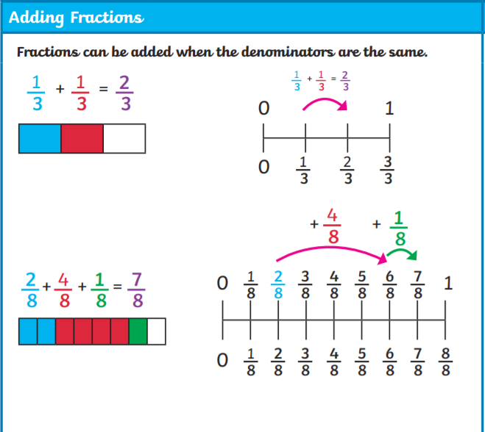
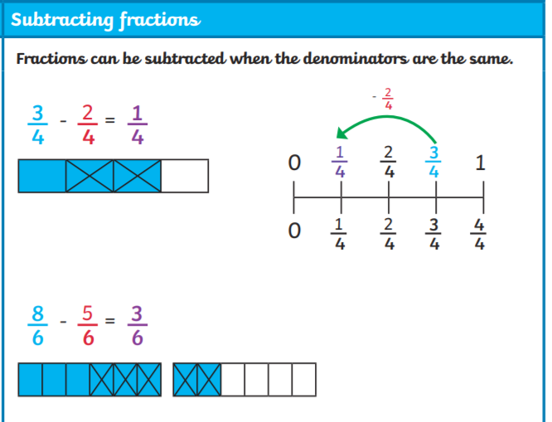
VIPs

-A fraction is a representation of a whole.
-A Proper Fraction has a numerator that is smaller.
-To find a fraction of a number, divide by the denominator and multiply by numerator.
-A fraction is a numerical representation for part of a whole.
-The numerator tells how many pieces of the whole the fraction represents.
-The denominator tells how many equal pieces the whole is divided into.
-Fractions with numerator 1 are called unit fractions.
-Fractions in which the numerator is more than or equal to the denominator are called improper fractions.
-Mixed fractions consist of a whole number along with a proper fraction.

Year 4 Knowledge Organiser: Fractions

Key Vocabulary
Numerator, denominator, unit fraction, non-unit fraction, equivalent, quantities, whole, halves, thirds, quarters, fifths, sixths, sevenths, eighths, ninths, tenths, elevenths, twelfths, quantities
Fat Questions

Why do we need fractions, what is the purpose behind them in everyday life?

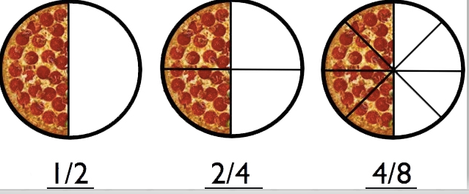

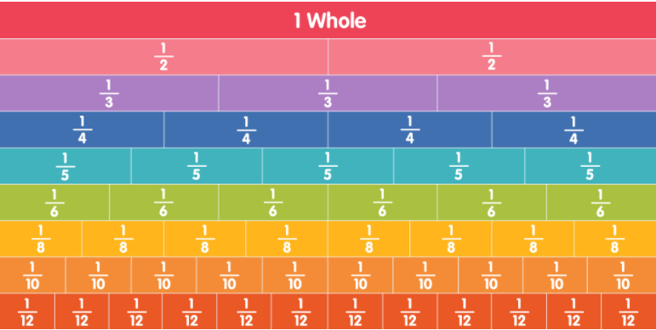
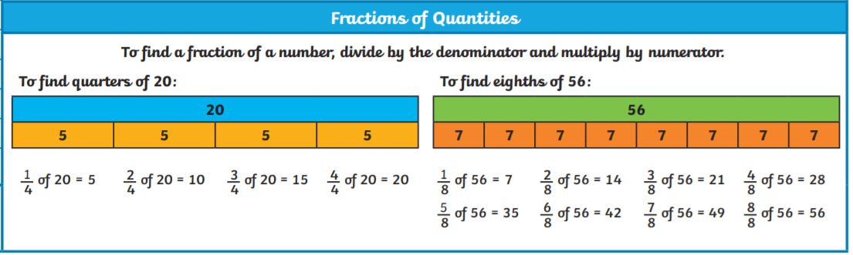
Intent
To build on current knowledge of fractions and identify how to add. Subtract and find fractions of quantities.

