Spring Term Overview - SCIENCE

Spring Term Book – One Day On Our Blue Planet
Topic(s) – Animals/Living Things and Their Habitats |  | Guide Time = 6 weeks
Assessment | Twinkl assessment (modified)  VIP quizzes | VIPs:  - Some things are living, some things are dead and some things have never been alive.  - Different types of animals have different characteristics.  - Animals are suited to the habitat in which they live.  - A microhabitat is a small area of a habitat.  - Some living things rely on each other to survive.  - Food chains show who eats who in a habitat and how energy flows from one animal to the next.  Fat Questions:  - What makes a home?  - Is a human an animal? Does it have a habitat?  - Do humans have a positive or negative impact on the habitats around them?  - How big can a habitat be?  - Is a habitat still a habitat if nothing lives there?
Links to prior learning (sequencing) and canon book | This unit builds upon the children's knowledge of animals and their basic structures, as taught in Autumn 1. This topic links to the canon text 'One day on our blue planet' as the Antarctic and its inhabitants is one of the habitats that will be studied.
Links to other learning (cross fertilisation) | This unit links to our learning in geography, as we will be learning about ocean habitats after locating the 5 oceans on a map. There are links to English through the canon text relating to penguins and other Antarctic creatures and their habitats.  The World Beyond us  How is a human habitat different to the habitat of the penguins in our canon text?  What types of habitats can be found across the world?  Which habitats pose the most challenges to survival?  Healthy Bodies Healthy Minds  What does it mean to have a home?  How do habitats support survival?  The Word Around Us  What habitats do humans live in, and how are we adapted to them?  What type of habitats are local to us?  Culture  Do all humans live in the same habitat?  How have humans adapted to different habitats?  Are animal habitats given the same rights as human habitats?  Modern Britain  How have humans impacted the different habitats of animals?  Do habitats change over time?  Technology In Action  What can be done to protect habitats that are in danger of destruction?  How is technology used to find out about animal habitats across the world?
Links to future learning | This topic will be further built upon in Summer 2 when the topic of habitats is revisited in relation to how seasonal changes affect different habitats and result in different adaptations being observed.
Character/Wider Development ('50 things, cultural capital, skills) | This unit of work encourages children to think about the animal population in their part of the world and beyond and encourages them to reflect on the impact humans are having on different animal habitats and the precautions that can be put in place to safeguard them for the future. There will be opportunities for spending time outside in a natural environment, investigating different habitats and microhabitats.

OVERVIEW OF TEACHING SEQUENCE

Key Facts/Learning | Learning Focus or Key Question | Learning Outcomes (NC) | Key Words/  Vocabulary | Greater Depth/SEND | Misconceptions | Activities and Resources
Lesson 1:  Living, Dead, Never Alive | Identify things that are living, dead and that have never been alive. | Explore and compare the differences between things that are living, dead, and things that have never been alive. | Living  Dead / Once alive  Never alive  Grow  Move  Man-made  Natural  Explain  Justify | GD: Children can be presented with more challenging pictures to sort and explain.  SEND: Depending on need, children could be given more straight forward objects to sort, or work in a group to sort the pictures. | Children may struggle to categorise natural materials such as wool, cotton and wood that were once part of a living thing.  Children may struggle to see plants and trees as living things. | Show the children some images from the canon text to begin with – what is the difference between them? Explain that some are alive – like the penguins, some are dead – like the fish they eat, and some things have never been alive – like the ice they stand on.  Watch the explanatory video Is it alive? - BBC Bitesize. Using the canon text, children can search though the pictures and find example of things that are living, dead, and never alive, and explain the justification behind their choice. LA or SEND children could be given a narrower choice - one page for example, or a selection of images.  Year 1 – Sort pictures into three categories – living, dead and never alive. Either stick pictures or write names into a list, depending on children’s abilities. Choose one picture and write a sentence justifying their choice.  Year 2 – Write a sentence to explain what each heading means (living, dead, never alive) and then give three examples of something from each category.  Deepen the Moment – When you cut your hair, is the hair living, dead or never alive?
Lesson 2:  Types of animal | Identify the features of mammals, amphibians, reptiles, birds and fish.  Name some animals that belong in each category. | Identify and name a variety of common animals including fish, amphibians, reptiles, birds and mammals.  Describe and compare the structure of a variety of common animals (fish, amphibians, reptiles, birds and mammals, including pets). | Fish  Amphibians  Reptiles  Birds  Mammals  Structure  Body  Wings  Gills  Scales  Legs  Tail  Fur  Warm-blooded  Cold-blooded  Claws | GD: Children could be introduced to a further category to explore – insects.  SEND: Depending on need, children could be given an animal in each category to use as a reference, and match animals with similar characteristics. | A misconception may occur around the understanding of the word’s ‘mammal’ and ‘animal’. | Show some images of animals from the canon text. Recap on living, dead and never alive – conclude that all these animals are alive. What type of animals are they? What is a penguin? If a penguin is a bird, is everything a bird? How do we know? Introduce the different animal classifications.  Play a game like the ‘corners’ party game. Place animal categories around the room, then show images of animals to the children – they must run to the correct category and explain their decision.  Year 1 – Label the animals, then match the groups to the correct description.  Year 2 – Sort animals into the correct classification by writing their names into a table. Children could also be challenged by explaining defining features of each animal classification.  Deepening the moment – answer ‘what am I?’ questions about each group. E.g. I have warm blood and fur – what am I?
Lesson 3:  Habitats and adaptations | Identify different habitats around the world and name some animals that live in each habitat.  Identify how some animals have adapted to their habitats. | Identify that most living things live in habitats to which they are suited and describe how different habitats provide for the basic needs of different kinds of animals and plants, and how they depend on each other | Habitat  Desert  Arctic  Forest  Woodland  Adaptation  Survival  Ocean  Antarctic | GD: Greater emphasis to be placed on explaining adaptations, rather than just simple sorting.  SEND: Depending on need, children could be given a narrower list of habitats with clear differences to support them in this task. | Children may believe that a zoo is a natural habitat.  Children may have limited experience of naming and recognising animals and may need assistance with this. | Show the image of the penguin from the canon text. Where does it live? Why?  Show different images, with the penguin in different habitats – does it live there? Why not?  Introduce the idea of habitats and show some examples from the slides. Watch the video at What is a habitat? | Habitats in KS1 and KS2 | Habitat learning acitivities | TheSchoolRun.  Year 1 – Match the animals to their habitats. Choose one animal and explain how it is suited to its habitat.  Year 2 – Match the animals to their habitats (using a wider range of habitats than Year 1). Or each habitat, explain some of the adaptations that the animals living there will use. Include knowledge of animal classifications covered in the previous lesson.  Deepening the Moment – Animals in zoos are often away from their natural habitats. How do you think this affects them? What do zoos need to do to help the animal survive?
Lesson 4:  Microhabitats | Identify a microhabitat and some creatures that may live there. | Identify and name a variety of common animals including fish, amphibians, reptiles, birds and mammals.  Identify and name a variety of plants and animals in their habitats, including microhabitats. | Habitat  Microhabitat  Minibeast  Insect  Survive  Living  Log  Tree  Leaf  Grass | GD: Children can explore the ways in which minibeasts have adapted to their microhabitats – legs for climbing, wings for flying etc.  SEND: Children could be supported by providing a tick list of potential microhabitat inhabitants for the children to tick off, rather than writing their own list. | Children may not understand the word ‘micro’.  Children may infer that a microhabitat is made of entirely small things, when in fact ‘micro’ refers to the area the habitat covers, rather than the actual size of its features. | Recap previous learning on habitats and introduce microhabitats – a small area of a habitat that is often home to small living things.  Year 1 – Go outside and list the microhabitats that can be found in the school grounds – choose one to investigate. What types of animals can be found living there?  Year 2 – As above, but investigate two different microhabitats (or split the class into two and investigate different habitats) what are the differences? What are the similarities?  Deepen the Moment – Do any minibeasts share your habitat? (Your home)
Lesson 5:  Food Chains | Show how animals are connected in the form of a food chain. | Describe how animals obtain their food from plants and other animals, using the idea of a simple food chain, and identify and name different sources of food. | Predator  Prey  Herbivore  Carnivore  Omnivore  Diet  Energy  Food  Consume  Apex Predator  Food Chain  Sun  Plant | GD: Children can be introduced to terms such as ‘apex predator’ to identify the end of their food chain.  SEND: Children can be supported by using the food chains mentioned in the book, and those demonstrated by the class teacher. | Children may not have the prior knowledge that our food consists of plants and animals. | Revisit previous learning on what animals need to survive – food, air, water, shelter. All these things are provided by a habitat. Look again at the penguins from the canon text. What do penguins eat? Penguins eat fish – but what do fish eat? Track the food chain back to the sun. Every living thing is part of a food chain that shows what it eats. Model and demonstrate.  Create a hanging food chain model:  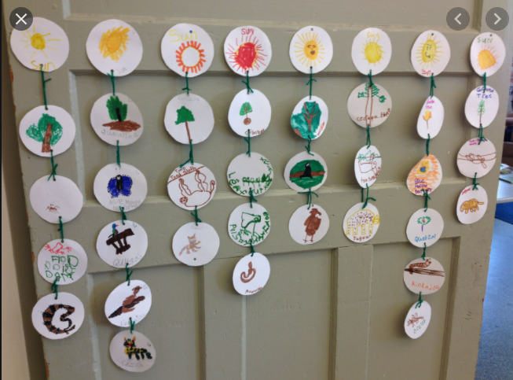  Deepen the Moment – Can you make a food chain for a human?
Lesson 6:
Assessment and completion.

Context (big picture learning)

This learning develops children’s understanding of different animals and their adaptations. It also provides opportunities for them to look critically at their environments and at themselves, as well as at the animals they are familiar with. This topic is revisited in the final half term.

